Second Open Print Competition – 15th November
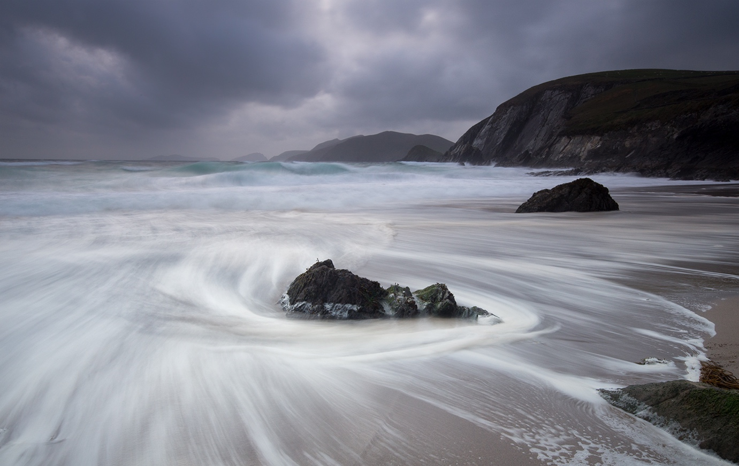
“Coulmeenoole Beach” by Jeremy Broome-Smith
The second of our Open Print Competitions was the subject of this week’s meeting of the IOM Photographic Society, being judged by Dennis Wood, Vice Chairman of the Western Society. Dennis is a frequent and welcome visitor at the IOMPS, always giving great value in his judging, and always with a very easy and supportive presentation style. This year, his commentary had a distinct “culinary flavour”, with allusions to photography being very similar to cooking – and the cook (or photographer) having to use skills to mix the various “ingredients” such as composition, colour, contrast, tonality etc to concoct the final product – the “dish of the day” or the print.
The Standard Group produced a range of excellent prints, Paul Dougherty winning the colour prints section with a lovely and very evocative image of a wheelwright craftsman making a cart wheel in a traditional way, the metal flange being hammered on to the wooden wheel. Lara Howe’s beautifully executed shot of two abandoned boats on Dungeness came out on top in the Mono section, the tonality and composition being noteworthy. In the Intermediate Group, Beryl Quayle and Joy Brodie traded places – Beryl winning the Colour section with a pin-sharp image of Liverpool Pierhead and the Liver Building taken from the sea, whilst Joy won the honours in the Mono section with a sepia image, apparently of a young miner against a sombre brick wall, the lighting artfully highlighting the subject. The Advanced Group provided a large entry in both Colour and Mono Prints, but only one winner in both sections – Jeremy Broome-Smith producing the winning images in both with both being seascapes but each given a widely differing treatment. His Colour image was a long exposure shot of a beach scene, the movement of the water around a rock in the foreground reduced to a swirl of mistiness, whilst his Mono entry was of a huge wave crashing against a massive rock cliff, the water cascading down the face, the action caught in great detail. Jeremy’s colour image – “Coulmeenoole Beach” – was awarded “best print in competition”. Club President Chris Blyth gave the vote of thanks for a well-constructed and well-delivered commentary by our judge.
The Society meets at the Art Society Building (Thie Ellyn) in Withington Road, Douglas, with all meetings starting at 7:30pm. Our next meeting on Wednesday, 29th November will include an Open Digitally Projected Images competition. Meetings are open to the public, and all will be given a very warm welcome. Full details of our programme can be found on our website at www.iomps.com.
Results : Standard Colour Prints – Paul Dougherty (1 & 4), Deb Turk (2), Lara Howe (3), Kevan Osborn (5 & 6). Mono Prints – Lara Howe (1), Deb Turk (2), Jonathan Carey (3). Intermediate Colour Prints – Beryl Quayle (1 & 3), Joy Brodie (2 & 4). Mono Prints – Joy Brodie (1 & 2). Advanced Colour Prints – Jeremy Broome-Smith (1 & 2), Ron Shimmin (3), Sue Blythe (4), Bob Servante (5), Chris Blyth (6). Mono Prints – Jeremy Broome-Smith (1 & 4), Barry Murphy (2 & 3), Sue Blythe (5), Bob Servante (6). Best Print In Competition – Jeremy Broome-Smith with “Coulmeenoole Beach”.

Nature Assignment Competition – 8th November

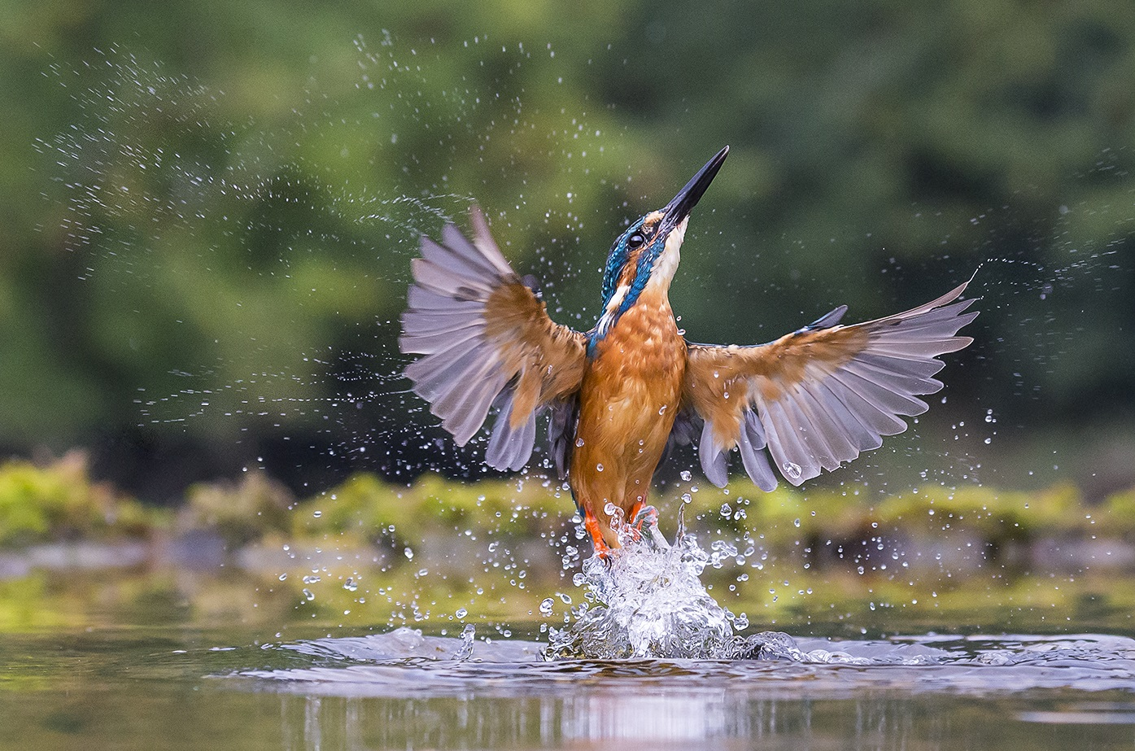
Best Image in the “Nature” assignment competition was “Kingfisher Angel” by Sue Blyth
Wednesday 8th November was the first of our assignment nights, the theme nature. We were lucky to be joined by Neil Morris, the Managing Director of Manx Birdlife. As well as a very experienced birder he is also a keen photographer; admitting he is a birder before a photographer, although he always carries his camera out with him whilst birdwatching. He provided great insight and comments on all the images seen on the night, making it a very valuable night.
First we viewed the print images. There was of high standard of images. There was a great variety of images from birds, other animals, plants and landscapes, making it a challenging night for Neil to judge. The standard colour print was first with Deb Turk winning with her image of beach grass. The mono prints category was won by Johnathan Carey with roots, a dramatic images of tree roots.
Intermediate colour was won by Richard Shafto with his image of three short clawed otters all looking at the camera, whilst the mono print was won by Beryl Quayle with courting jackdaw image. Neil described the image as terrific.
The advanced group produced some incredible images. Barry Murphy won the colour class with his close up image of a cuckoo taken on the Calf of Man. Neil described it as a publishable print. The mono class was won by Sue Blyth with Leopards Stare. A beautiful close up picture of a leopard. The overall winner of the print competition was Barry Murphy’s Cuckoo.
After a short tea break we viewed the digital prints. There were more images in the digital section so Neil had to shorten his informative comments. Standard colour was again first. It was won by Tim Norton and his beautiful image of a peacock close up. Standard mono was also won by Tim Norton with an image of a primate siting and apparently thinking.
Intermediate colour was won by Joy Brodie with an image of 2 damselflies joined together in a heart shape. Beryl Quayle won the colour category with an image entitled I’m watching you.
Again the advanced class produced some high quality images in the digital category. Sue Blyth’s kingfisher angel was the colour class winner, with a stunning image. With Jeremey Broome-Smith winning the mono class with his extreme macro image of two flies looking at each other. A compilation of around 72 photographs made up the image. Sue’s kingfisher image took best digital image and also overall winning image on the night. Sue also received the award for the best image from the three way battle with Southern and Western photographic societies back in October, which the club won overall and will subsequently be hosting next year.

The week finishes on a “high”!
By Chris Blyth
This week proved exceptional for the IOM Photographic Society with our regular weekly meeting being well-attended for two super presentations, whilst on the day following, the island’s three photographic clubs met for their annual “digital battle”.
The Wednesday meeting opened with a presentation by the President of the Western Photographic Society, Dorothy Flint ARPS AFIAP BPE4* – one of the most talented and highly qualified photographers on the Island – and a lady who quite definitely “goes the extra mile” to get her images. Her presentation of some 60 prints showcased some of her favourite work over the past decade or so – and included work which covered her technical transition from film based images to digital. Our audience were spell-bound with the wide range of subject matter on display – natural history, landscapes, portraits and some highly imaginative and very artistic “water portraits”. My own favourites included her winter snowscapes from Iceland and Greenland – evocative images with lovely compositions and great detail.
The second part of the evening was a digital presentation by two of the club’s rising stars, Barry Murphy and Sue Leeming, and covered a holiday trip to Menorca. The presentation was very well put together and included a brief explanation of the geography and history of the island, followed by a myriad of images showing the landscape, wildlife, flowers, beaches and towns – the photography was delightful, the approach quite refreshing, and all enhanced with an excellent commentary.
A very well deserved vote of thanks to all three presenters was given by Club President, Chris Blyth.
On the following evening, all three of the Island’s photographic societies met in Peel for the Annual 3-Way Digital Battle – the one occasion in the year when all three clubs meet in competition. The Western have been holders of the title for the past two years, so had responsibility for organising this year’s event. All three clubs were required to enter 30 images each, a total of 90 images giving our judge Adrian Cowin the mammoth task of commenting on each and marking each out of a maximum of 20 points – and the club with the highest total at the end of the evening claiming the prize…. Each club provided excellent images and it made for an exciting evening as running scores were being kept around the room. At the end, the IOM Photographic Society came out on top, with the Western Club in second place and the Southern close behind.
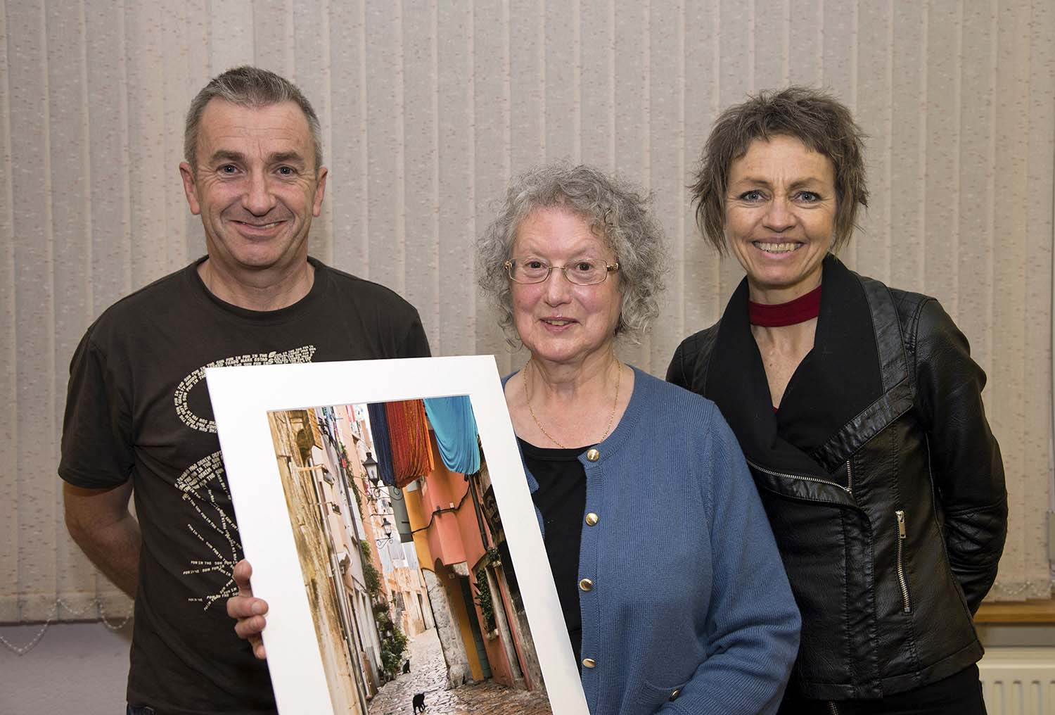
CAPTION: Barry Murphy, Dorothy Flint and Sue Leeming who gave us a showcase of excellent photography recently

Digital Competition 18th October 2017
By Lara Howe
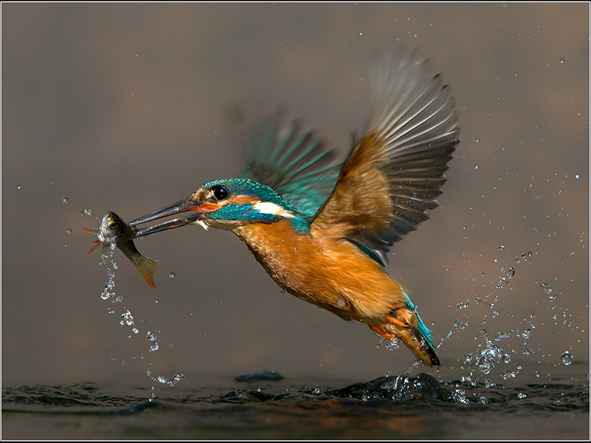Best Image in the first digital open competition of the season was ‘Kingfisher With Fish’ by Jeremy Broome-Smith
It was the first open digital competition for the new season and standards were high. We were lucky to be joined by Doug Allan from the Western Photographic Society who had kindly offered to judge the prints for the night. He is a keen walker as well as a keen photographer, which probably explains his passion for natural history and travel photographs. Before the judging began discussions were had whether to just judge the entries without scoring or whether to score them. The club were mixed but Doug decided to give it a go. It worked well and gave a great insight into how the images ranked.
First up was the Standard colour class. There weren’t many entries but what it lacked in numbers was made up by the quality of the images. Patricia Larkham came in third with 17 points with Rolls reflections. A close up of a Rolls Royce. Michael Howland’s image of an RNLI crew member jumping in the sea made us all shudder with the thought of how cold that water looked. The expression on the crew members’ face certainly suggesting that. He received a very well deserved 18 point and second place. In first place was Lara Howe with a half body portrait image of a young man with a colourful tattoo, scoring a winning 19 points.
Next was the Standard mono class. In third was Lara Howe with an image of a Venice waterfront, scoring 17 points. Johnathan Carey Old School Railings came in second with 18 points but the worthy winner was Peter Keena’s winter beach walkers. A dramatic image scoring 19 points.
The Intermediate colour class then followed. Again there weren’t many images but the standard was just as high. Joy Brodie’s portrait of Amy scored 17 points and third place. Beryl Qualye’s Butterfly girl was a bright image that stood out, scoring 18 points and gaining second place. The winner of the category was also Beryl Quayle’s with her image of a Glorious Dahlia flower, scoring 19 points.
The Intermediate mono class did not disappoint either. Richard Shafto’s Eairy Beg cottage image scored a respectable 17 points and gain him third place. Joy Brodie scored an equal 17 point but came in second place with her Deserted image. Beryl Quayle won the category with Dandelion clock after the rain, scoring 19 points.
The majority of images from the night came from the Advanced category. Sue Blyth came in third with an image of a diving gannet captured just at the right time. Scoring a very respectful 19 points. Jeremy Broome-Smith came second and first with Going for Gold and Kingfisher with fish, respectively. The stunning kingfisher image capturing the moment the bird caught its fish. Both scoring 20 points each. Doug commented that any of these three images were worthy winners.
The Advanced mono images were of equal standard as the colour images before. The image of an Abandoned slate mine gave Jeremy Broome-Smith 18 points and third place. Sue Blyth took second place with Left to rot, an image of rotting boats, with a score of 19 points. However, Barry Murphy took the winner place with the Big Girl Weeps, scoring 19 points. The image of the Dhoon waterfall was stunning. A great play on the name of the image too. However, the overall winner for the night, and best in competition went to Jeremy Broome-Smith for his Kingfisher and fish image. A worthy overall winner. An image anyone would be proud to have taken.

Open Print Competition – 11th October
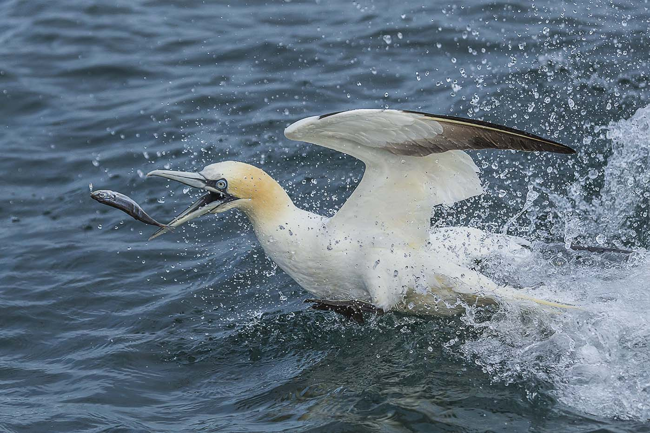
“Gotcha” by Sue Blythe
An “Open Prints” competition provided the entertainment for this week’s meeting of the IOM Photographic Society, with Mike Radcliffe acting as our judge. Mike is an experienced professional photographer, with his own website showcasing many of his images. These demonstrate his excellent understanding of just how to use light to give drama and atmosphere to an image……. so an ideal person to judge one of our competitions.
Entries throughout were of a high quality, the commentary was easy, nicely paced, with every image given full consideration and – where appropriate – helpful suggestions for possible improvement. Our lady members proved dominant, taking first place in all but the Intermediate Monochrome section. In the Standard Group, a lovely shot of the Venice waterfront gave Lara Howe the honours in the mono section with Deb Turk as runner-up. The tables were then turned in the colour section, with Deb’s intriguing and well-handled shot of a painter apparently standing on the roof of a camper-van winning and Lara in second. In the Intermediate Group, Richard Shafto gained a first and second in the mono section, his winning shot being an excellent image of a spider in a window, the light and texture of the plaster wall well captured, with Beryl Quayle chasing hard in third. They then traded places in the colour section, with Beryl taking both first and second places – her winner being of a beautiful peacock butterfly – and Richard following in third. In the Advanced Group, Sue Blythe swept the board, winning both the Mono and Colour sections – her mono entry a portrait of a competitor in the Toughmann event, determination clear in her expression, whilst the colour image was of a gannet caught just at the moment of catching a fish, the detail pin sharp. The gannet also gained the award of “best image of the night”.
The Society meets at the Art Society Building (Thie Ellyn) in Withington Road, Douglas, with all meetings starting at 7:30pm. Meetings are open to the public, and all will be given a very warm welcome. Full details of our programme can be found on our website at www.iomps.com. Our next meeting on Wednesday, 25th October will include two presentations, the first of prints by Dorothy Flint, to be followed by a travelogue of Menorca with Barry Murphy and Sue Leeming.
Results of Open Print Competition – Standard Group Monochrome : Lara Howe (1), Deb Turk (2 & 3), Jonathan Carey (4). Colour : Deb Turk (1 & 3), Lara Howe (2), Kevan Osborn (4), Jonathan Carey (5), Paul Dougherty (6). Intermediate Group Monochrome : Richard Shafto (1 & 2), Beryl Quayle (3), Joy Brodie (4 & 5). Colour : Beryl Quayle (1 & 2), Richard Shafto (3 & 4), Joy Brodie (5 & 6). Advanced Group Monochrome : Sue Blythe (1), Jeremy Broome-Smith (2 & 3), Chris Blyth (4), Ruth Nicholls (5), Chris Nicholls (6 & C), Ron Shimmin (C). Colour : Sue Blythe (1 & 5), Barry Murphy (2), Jeremy Broome-Smith (3 & 4), Chris Nicholls (6 & C), Ron Shimmin (HC), Bob Servante (C). Best Image in Competition – Sue Blythe with (Gotcha)

Steam Railway Workshops Visit
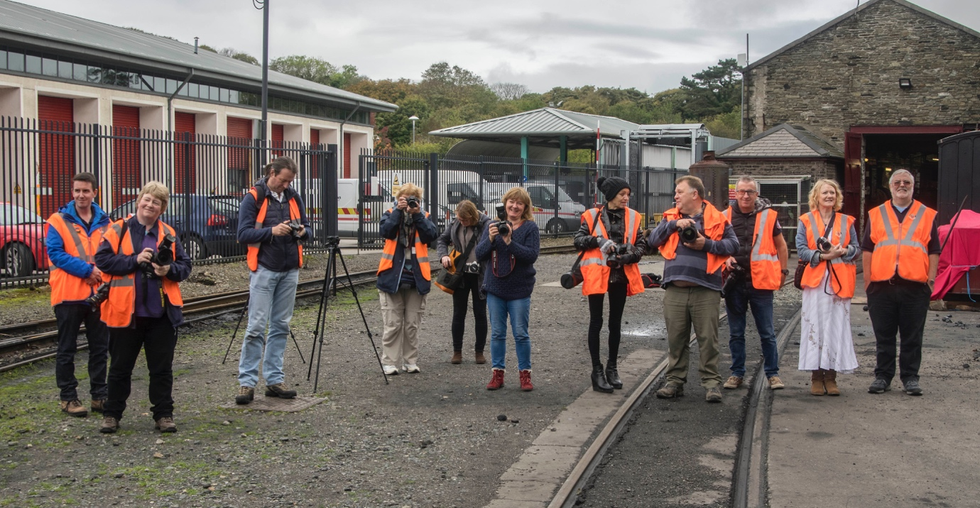
The opportunity to visit the Douglas Steam Railway workshops and signal box – both of major historic significance – was readily seized by members of the Society on Sunday 8th October. The group of members – “we few, we happy few, we band of brothers (and sisters)” – were escorted by members of the IOM Heritage Railways Volunteer Group who generously gave us their time, and shared with us their knowledge and enthusiasm. It proved a great afterno…on for an outing and much enjoyed as an opportunity to practice camera use and to socialise. And just maybe we shall see some entries as a result in competition later in the season….
Chris Blyth
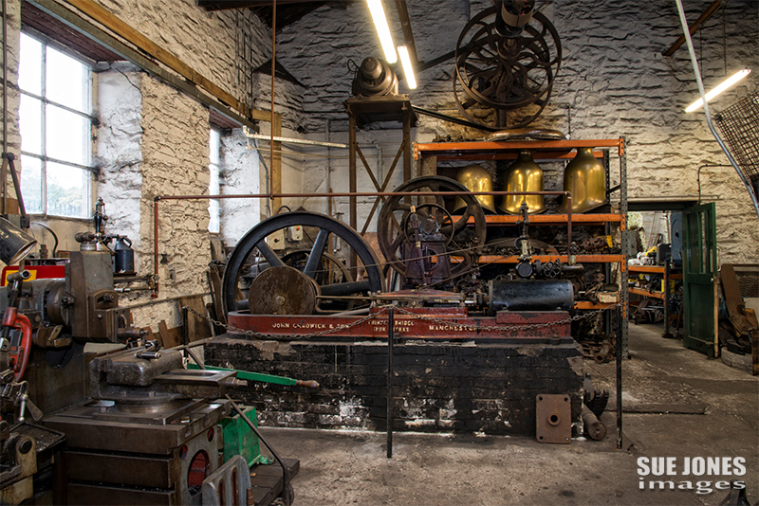
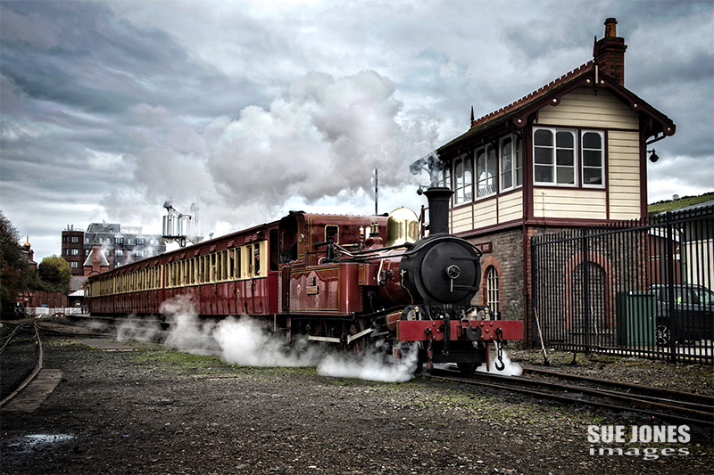
This week’s meeting of the IOM Photographic Society proved to be an evening to remember – an evening when everyone attending thoroughly enjoyed two excellent presentations by skilled local photographers.

The Sulby River, Old Douglas and Colour Profiling
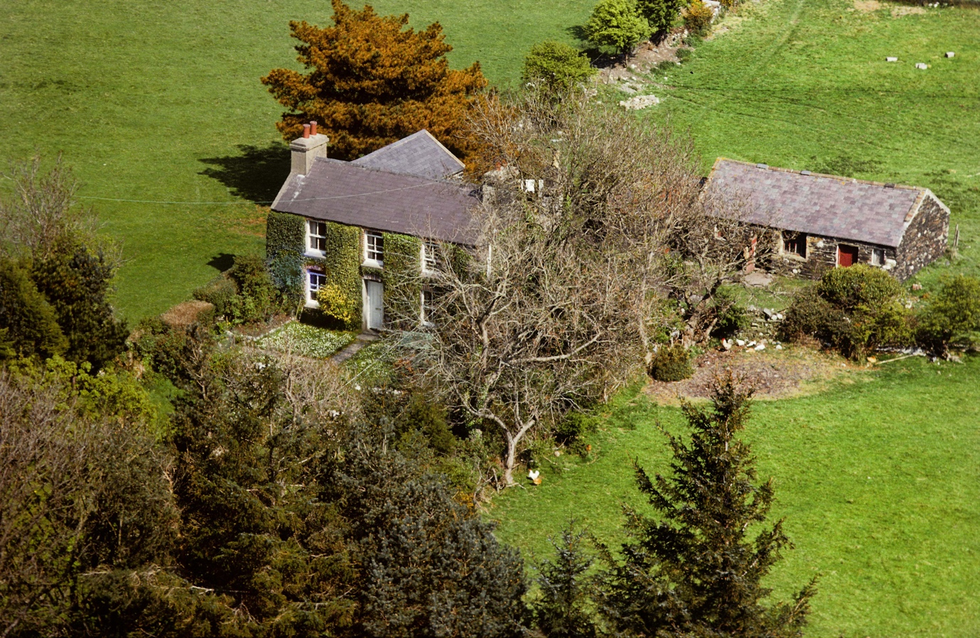
“Dolvetch” in the Sulby Valley, one of Ron and Brenda Shimmin’s 35mm slide film images from their audio-visual presentation about the Sulby River
On 4th October the evening started with a master class in audio-visual presentation from the age of film – a slideshow of the Sulby River by Ron Shimmin ARPS DPAGB and his wife Brenda LRPS. The sequence was made in the late 1970’s, shortly before the building of the Sulby Dam and thus of some historical importance. Brenda’s family owned property in the Sulby valley at the time, which was the justification for the making of the show. The slides – done on Kodachrome 25 – were in excellent condition, as was the twin lens projector – and what a pleasure to see genuine top quality images, properly exposed on slide film in our digital age! The commentary proved just right – spare, beautifully spoken and with some humour – and with a well-chosen pastoral music accompaniment matching the imagery. Ron and Brenda finished their presentation with a miscellany of slides of “old Douglas” and Douglas promenade – the audience totally engaged as they were reminded of the town as it was, the crowds on the beaches, and the harbour with the Steam Packet boats.
By contrast, the second half of the evening was a right up-to-date technical tour-de-force, and comprised a presentation by our Competitions Secretary, Jeremy Broome-Smith, on the very complex and very important topic of colour space and profiling for users of digital cameras. Jeremy fortunately kept the discussion at a non-technical level, illustrating his points with relevant images showing some of the issues and difficulties which may arise in printing or projecting digital images if profiling has not been done. Jeremy’s presentation finished with a number of suggestions for our members on camera controls and an exploration of the “settings” available within a camera’s digital menu – which proved highly enlightening and very helpful.
Club President Chris Blyth gave the well-earned vote of thanks to the speakers.

Bebington Salon 2017
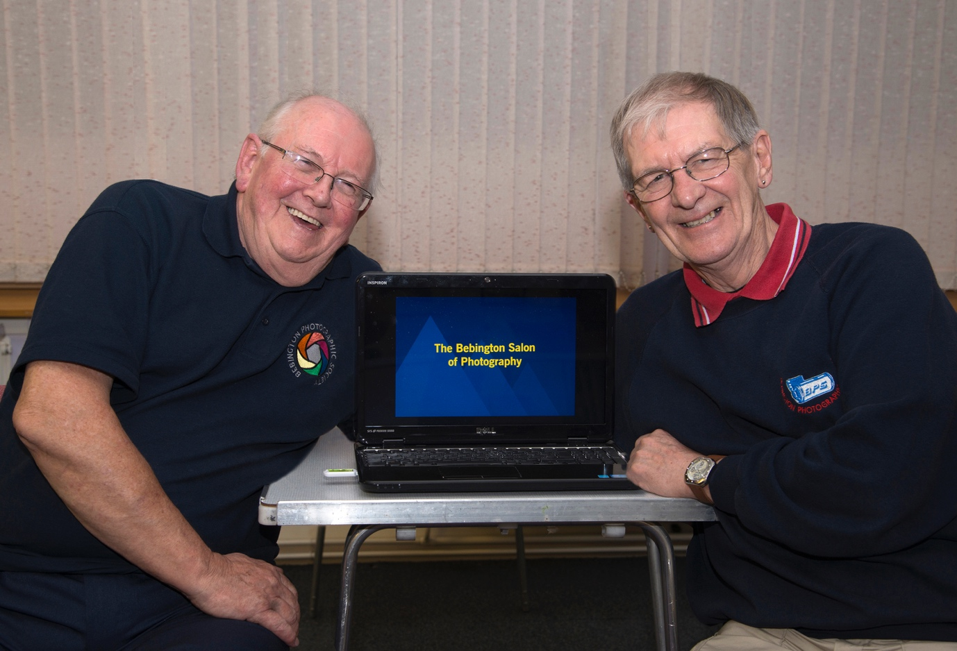
Bob Dennis APAGB, CPAGB, AFIAP,BPE4*and John Dougherty APAGB who presented the 2017 Bebington Salon of Photography
As the start to the new season of regular weekly meetings, the IOM Photographic Society was this week delighted to have a public showing of the “2017 Bebington Salon of Photography”, presented by Bob Dennis APAGB, CPAGB, AFIAP,BPE4*and John Dougherty APAGB. The Salon is highly regarded as one of the top photographic shows in the UK, and was presented as a digitally projected slide show, comprising more than 500 images in total. These were competitively selected from an entry of more than 3,200 images, each acceptance then accruing points counting towards the winning of a British Photographic Exhibition “crown” award. This year’s exhibition was noteworthy for the number of Manx photographers whose images were accepted for the Salon and a major tribute to the artistic talent on the Island. In particular, both Ruth Nicholls and Sue Blythe had images awarded “highly commended” whilst Sue Jones earned a “commended”.
Having been competitively selected, the photography was of outstanding quality, covering natural history, open colour, open mono, creative and landscape – superb images that, despite the poor weather, provided a rapt audience with delight and pleasure for a most rewarding evening.
The club then had a special evening on Friday when Bob Dennis spoke on the subject of “What Judges Are Looking For…” – a presentation with some robust and sometimes provocative comments which included magazine and calendar submissions, copyright, and competition rules – but made clear the importance (as always) of composition, colour, and impact on the viewer.
Chris Blyth

Toughmann Challenge 5th August

Mud, Mud, Glorious Mud….
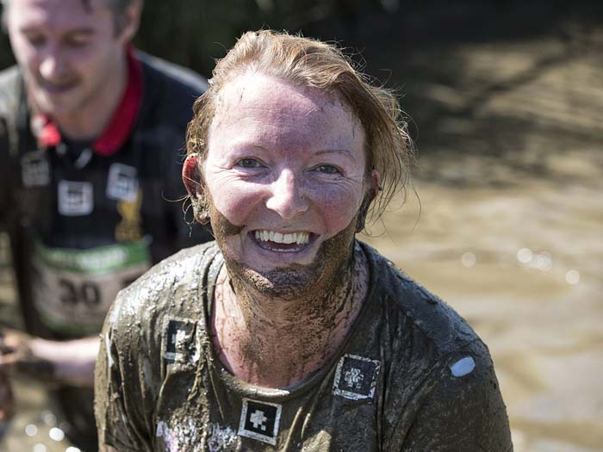
“Lara” – Image by Jeremy Broome-Smith
Tough Mann Experience – More Mud !
I woke on the morning of the 5th August with excitement and apprehension. Today was the day, the Tough Mann challenge had arrived. I’d never done anything like this before so I didn’t know what to expect. It turned out to be a great day. Although it was a challenge, especially that hill at the start, and very muddy, it was great fun. The sun was even shining.
The first challenge was getting up the hill. Once I reached the top, well I’m sure it was actually a mountain, I felt exhausted. Definitely something I didn’t want to do again but some mad people were doing two laps of the course! But the worst was behind me. It was all downhill from here on in, or so I thought. The next stage involved lots and lots of mud. Which was actually quite nice as long as you didn’t get stuck. Some sensible people had taped their shoes to their feet! Thankfully I managed to hold on to both trainers. By the time I’d waded through it all and ducked under the thick mud, completely submerged, I must have looked like a swamp monster! But there was no stopping me now.
There was plenty more to come through various obstacles, oh and plenty more mud too. One of the toughest had to be the high wall where it really was all about team effort. I would never have gotten over it without some new friends. I then managed to help a few people over the top too. The tunnels were muddy, the walls slippy, and the cargo net sticky. And there was plenty more in between. And it wasn’t demoralising or demotivating at all when I was overtaken by a guy on his second lap of the course! Especially as he was running it like it was his first!
The final stretch was just as challenging as the rest of the course. I had to climb, with help, over a wooden overhanging wall, then a tall cargo net on an A-frame, a refreshingly cold ice bath, and then across the pond via ropes to the finish line, with a smile on my face.
It took 4 showers to get all the mud out of my hair! and my pale blue T-shirt will never be the same again. Strangely though I really enjoyed myself. It was such a great event and I can’t wait to do it next year.
Lara Howe
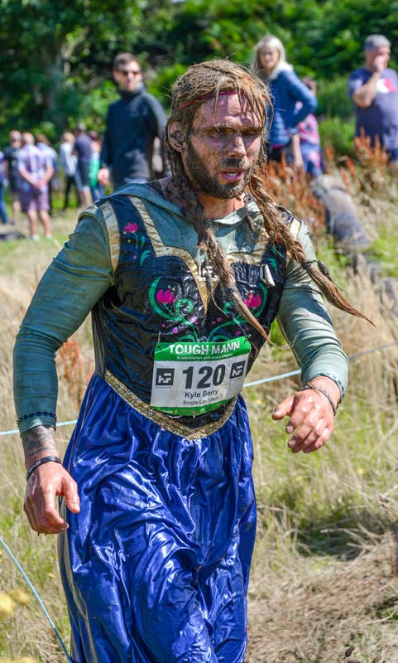
“Dress Optional” – by Bob Servante
Unfortunately, due to a “Bug” or some such ailment, I was unable to do my 20k two lap Toughmann Challenge and so I decided to photograph it instead. The site plan indicated two main viewing locations, one within a 5 minute walk and the other 15 minutes away. I opted for the 5 minute one. Jeremy (Broome-Smith) was also in attendance as a photographer, and he opted for the full 15 minute one, so we parted and went our separate ways. My location was spread over about 4 acres and consisted of various mud pools, climbing ramps and ditches.
Lighting was good and so I was able to use suitably fast shutter speeds to catch the action along with the depth of field I wanted. Two hazards for photographers to consider are if you get close enough for an uninterrupted view, you accept the risk that you get splashed with mud. The other one is by standing a little clear and using your zoom, you run the risk of people moving in front of you, just as one of the Islands Professional Photographers did to me who just pushed in front to get his shots.
To sum up, a good afternoon with plenty of opportunities for some great images and congratulations to our very own Lara Howe, who was on the wrong side of the lens, by competing – and getting very muddy !!.
Bob Servante
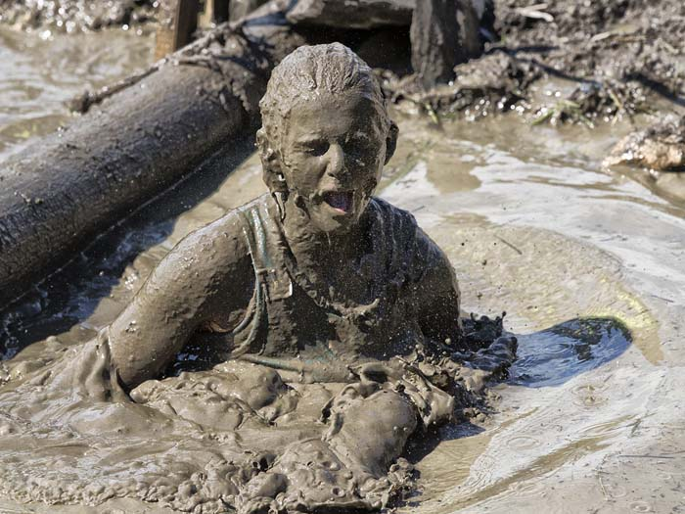
“Tough Mann” – Image by Jeremy Broome-Smith

Visit to the Wildlife Park
A members outing to the Wildlife Park at Ballaugh, organised by our webmaster Richard Shafto, took place on Saturday 15thJuly, with 10 members (or their family) taking part. Richard Halsall, one of the wardens at the Park gave generously of both his time and his knowledge of the animals, plus giving superb access to several of the enclosures.
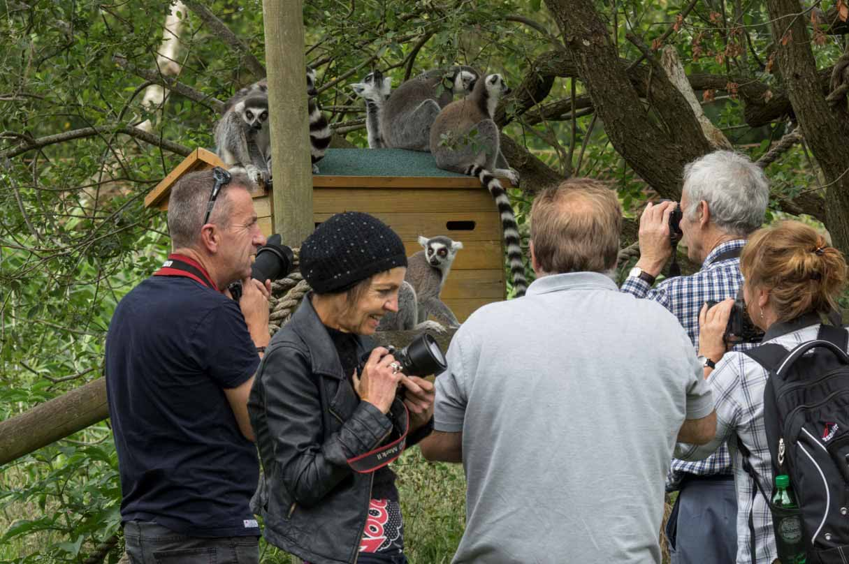
With the added benefit of warm and sunny weather, some excellent close-up shots of the various species was possible – and no doubt will feature in some of our competitions in the upcoming season.
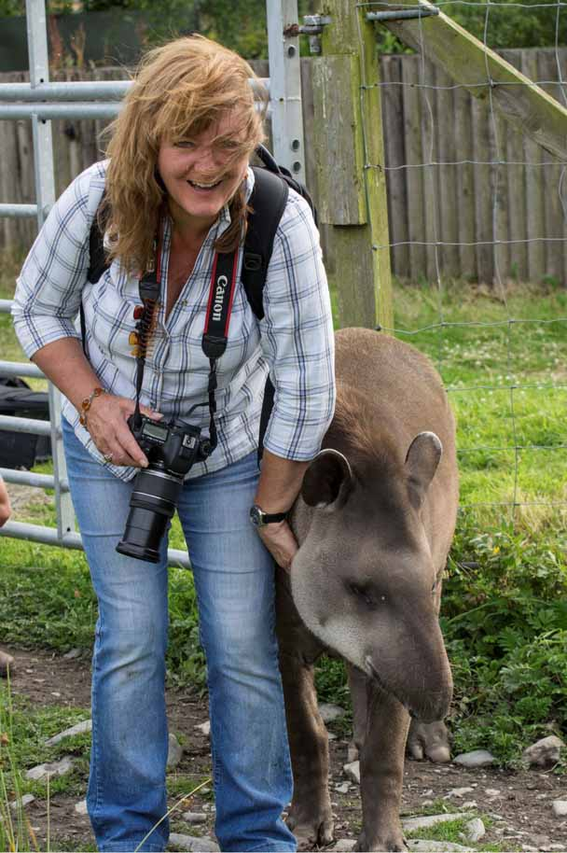
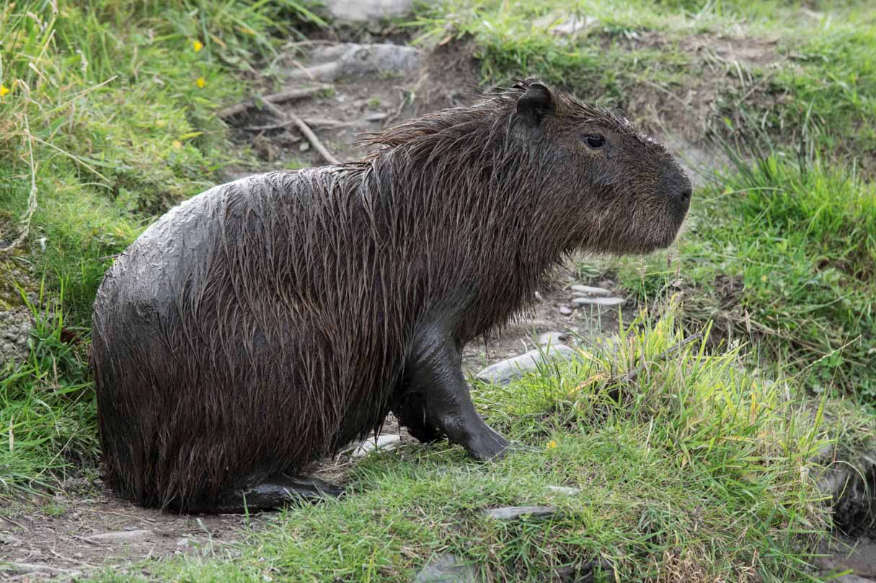
Meantime, the next members outing is scheduled for Sunday 30th July at the Andreas RaceWay – details as to times and entry fees have already been circulated. We look forward to seeing many members, family and friends at this event – and yes, with cameras at the ready !
By Chris Blyth

4th May 2017 – Year Finishes on a “High”
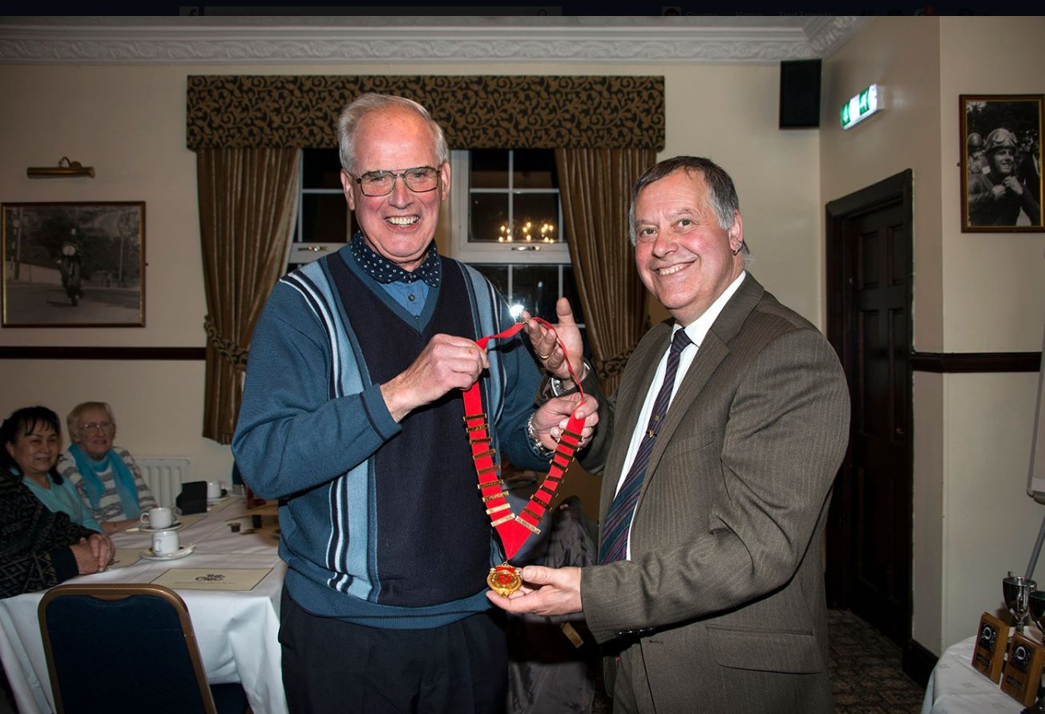
Out going President Tony Curtis hands over the chain of office to new President Chris Blyth
The Annual General Meeting and the Annual Dinner and Prize Presentation evening marks the end of the official season of regular weekly meetings of the IOM Photographic Society, which has included an excellent programme of competitions, presentations and practical demonstrations.
External speakers are always given a very warm welcome, and this year have included Phil Kneen, a local professional with a dedication to the use of film rather than digital …for his work. Dr Jeremy Paul proved an ever-popular speaker with a superb presentation on several of his latest expeditions – firstly to Costa Rica and then to Yellowstone National Park. Other speakers included John Keelan, showing his skills with images from local musical productions at the Gaiety, whilst Charles Guard gave an amusing and eloquent presentation of his work filming documentaries, largely about the Isle of Man.
Club members have also proved willing to demonstrate their prowess, with presentations by Chris Nicholls (Italy), Ruth Nicholls (Croatia), Bob Servante (Birds of the Farne Islands), Richard Leach (Lightroom), Tony Curtis (Studio Portrait Lighting), and John Phipp (Bali) – each in its own way giving ideas and inspiration to help other members improve their own skills.
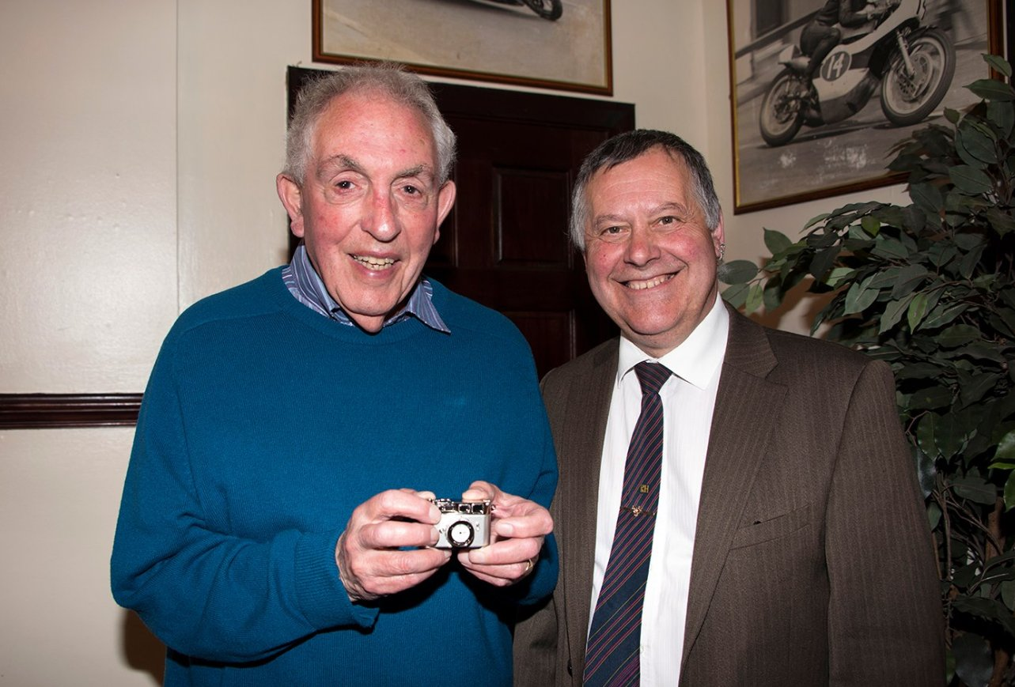
Ian Lumsden who is retiring from the committee after sixteen years receives a Camera Clock from out going President Tony Curtis in thanks for everything he has done for the IOMPS
Competition in our various sections has been fierce, in particular in our Intermediate and Advanced groups, and the club trophies are being shared widely at the year-end presentation. Our gratitude goes as ever to our various judges during the year – who are given the task of commenting on the entries and hopefully giving helpful encouragement for the future. A special mention goes to Christine Widdall MPAGB EFIAP FBPE, who judged our Annual Competition – a mammoth task over two days, given nearly 200 prints and over 200 digital images, and then having to finish each evening with a presentation of her own work – and both with an emphasis on the fun and enjoyment which our shared enthusiasm can provide. Our thanks also go the Arts Council for their continued support of this event and of the club.
The season finished with several “firsts” – our two competitions with clubs on the “other island” are always watched closely as they are the only opportunities to measure ourselves against comparable off-island photographers – and for the past 6 or so years, we have always been bested in the final results. However, this year, we have won both, in a massive boost for club members and a clear demonstration of our improving skills.
But the AGM is not the end of our activities. With the better light and longer days, our cameras come out of their cases and the action is renewed ….. and what better time for anyone looking for advice and guidance on how to get the best from their equipment than to join one of our summer outings where our friendly members will be on hand to help? Full details of our programme and contact details will be found on our website www.iomps.com
By Chris Blyth
Courier Report 13122017
“In the bleak mid-winter, frosty wind made moan ….“ as the carol by Christina Rossetti says, and as was evident for this week’s meeting of the IOM Photographic Society when, amidst a flurry of sleety hail and snow, only our most determined members turned out for a showing of the latest Lancashire and Cheshire Photographic Union print portfolio and for our Christmas social.
The folio, comprising some 60 A3 prints, included a wide selection of genres and which was perhaps of a higher and more enjoyable quality than has been apparent in some recent folios. The images had been chosen from submissions by the various clubs within the L&CPU federation (more than 90 in total). The images had been assessed by 3 judges, each marking on a score of 1-5 (thus a maximum of 15 points), and generally scoring at least 11 or 12 points to be chosen for the folio. Our members enjoyed making their own assessments and giving their scores – but the objective is to provide ideas for one’s own images and hopefully encouragement.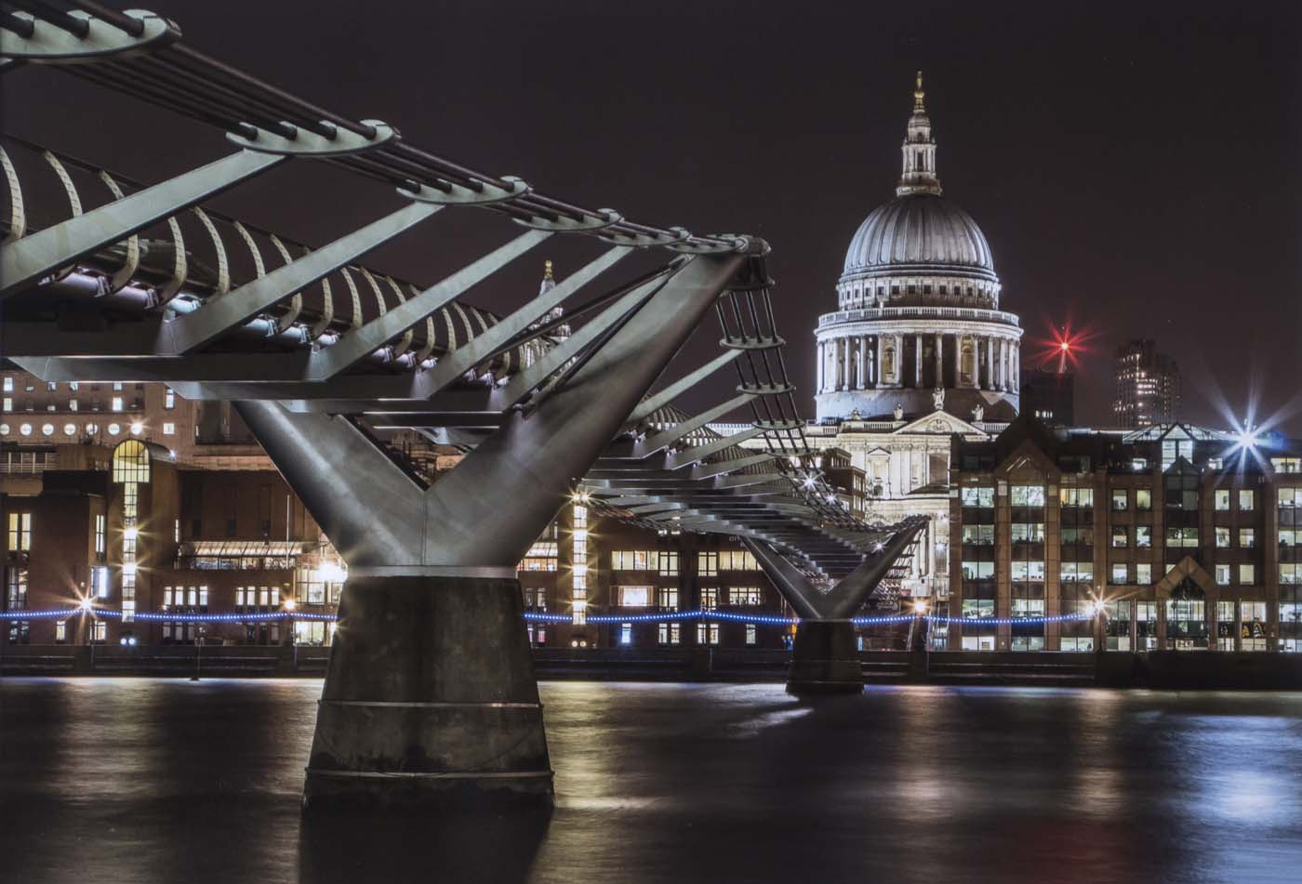
The natural history shots were excellent, with some stunning images of birds and insects in glorious detail in particular – and making clear that only the most meticulous attention to quality and “the decisive moment” for one’s images will produce a winner in this category. A range of portraits – especially in monochrome – found wide approval, as did the landscapes, though several motorcycling images were dismissed as pretty run-of-the-mill, perhaps not surprisingly given our local opportunities. Two images by photographers from the Western Society were included in the folio and were warmly applauded by members.
Our next meeting is on Wednesday 3rdJanuary when Club President, Chris Blyth, will be showing a presentation on “Venice- La Serenissima”, and members will be showing images of Cregneash – a challenge set up over the summer months to produce 10-12 images each, to encapsulate one’s thoughts and impressions of the culture and lifestyle of living in the village. The club meets at the Art Society Building (Thie Ellyn) in Withington Road, Douglas, with all meetings starting at 7:30pm. Meetings are open to the public and all will be given a very warm welcome. Full details of our programme can be found on our website at www.iomps.com
The Isle of Man Photographic Society is supported by the Isle of Man Arts Council

