19th February 2017 - Assignments for 2017 - 2018
The assignment topics for the 2017 - 2018 season are:
Natural History
Record
Human Anatomy
The Isle of Man Bank Cup assignment is:
Manx Ruins

16th February 2017 - Dr Jeremy Paul - "Travels of a Wildlife Artist"
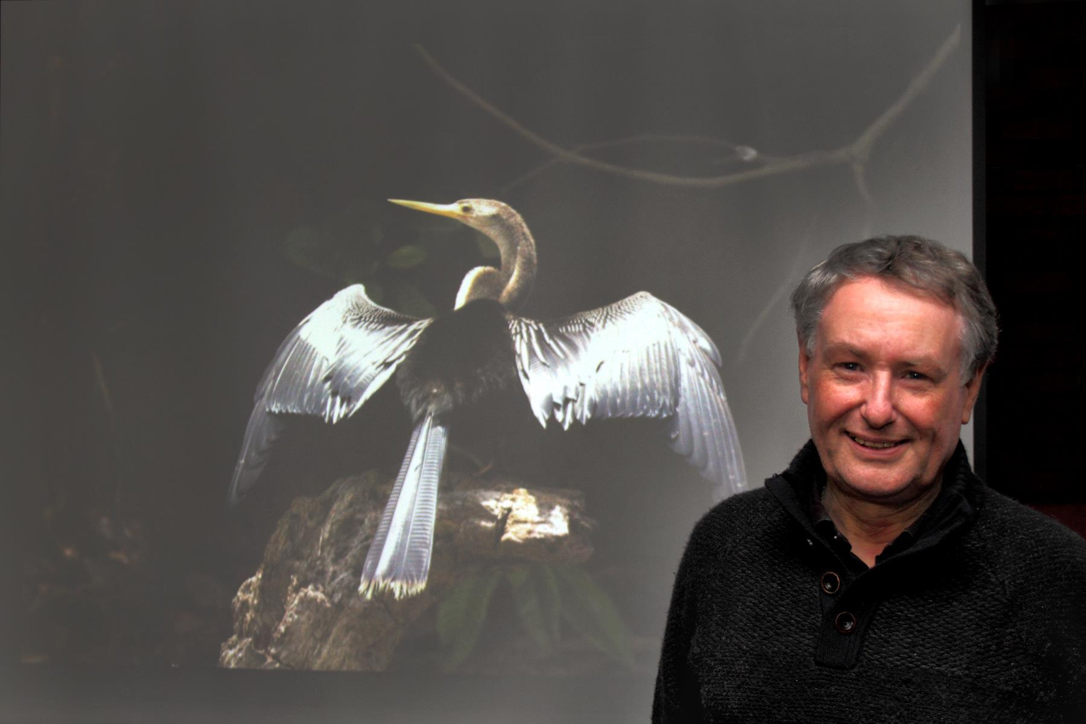
Dr Jeremy Paul with one of his many excellent images
From far and wide they came, some even queuing outside Thie Ellyn an hour before the start time! All were eagerly anticipating the latest presentation by local photographer and artist, Dr Jeremy Paul. So, by 7.30 pm, there was another full house and we were pleased to welcome ‘fans’ and guests from other photographic clubs for this special evening.
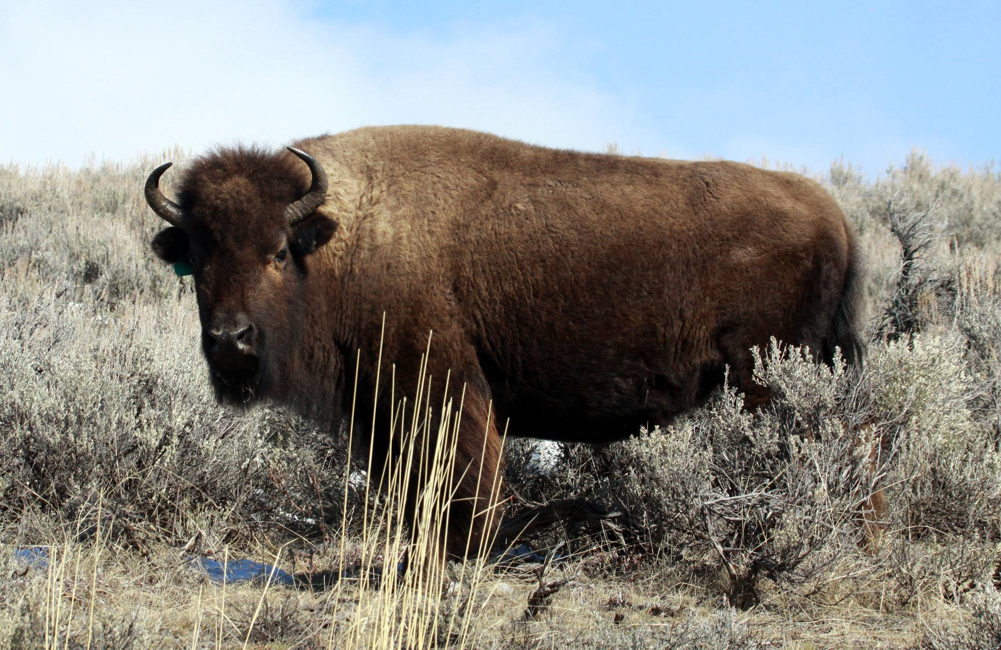
Bison, Yellowstone National Park by Jeremy Paul
A former Marine Biologist and researcher, Jeremy has been a wildlife artist for almost 30 years and has a string of prestigious credits to his name, including BBC Wildlife Artist of the Year on 3 occasions. In spite of having a well-earned reputation, making him much in demand, he has long been a good friend to the Society to which he gives generously of his precious time to visit us periodically, for which we are most grateful.
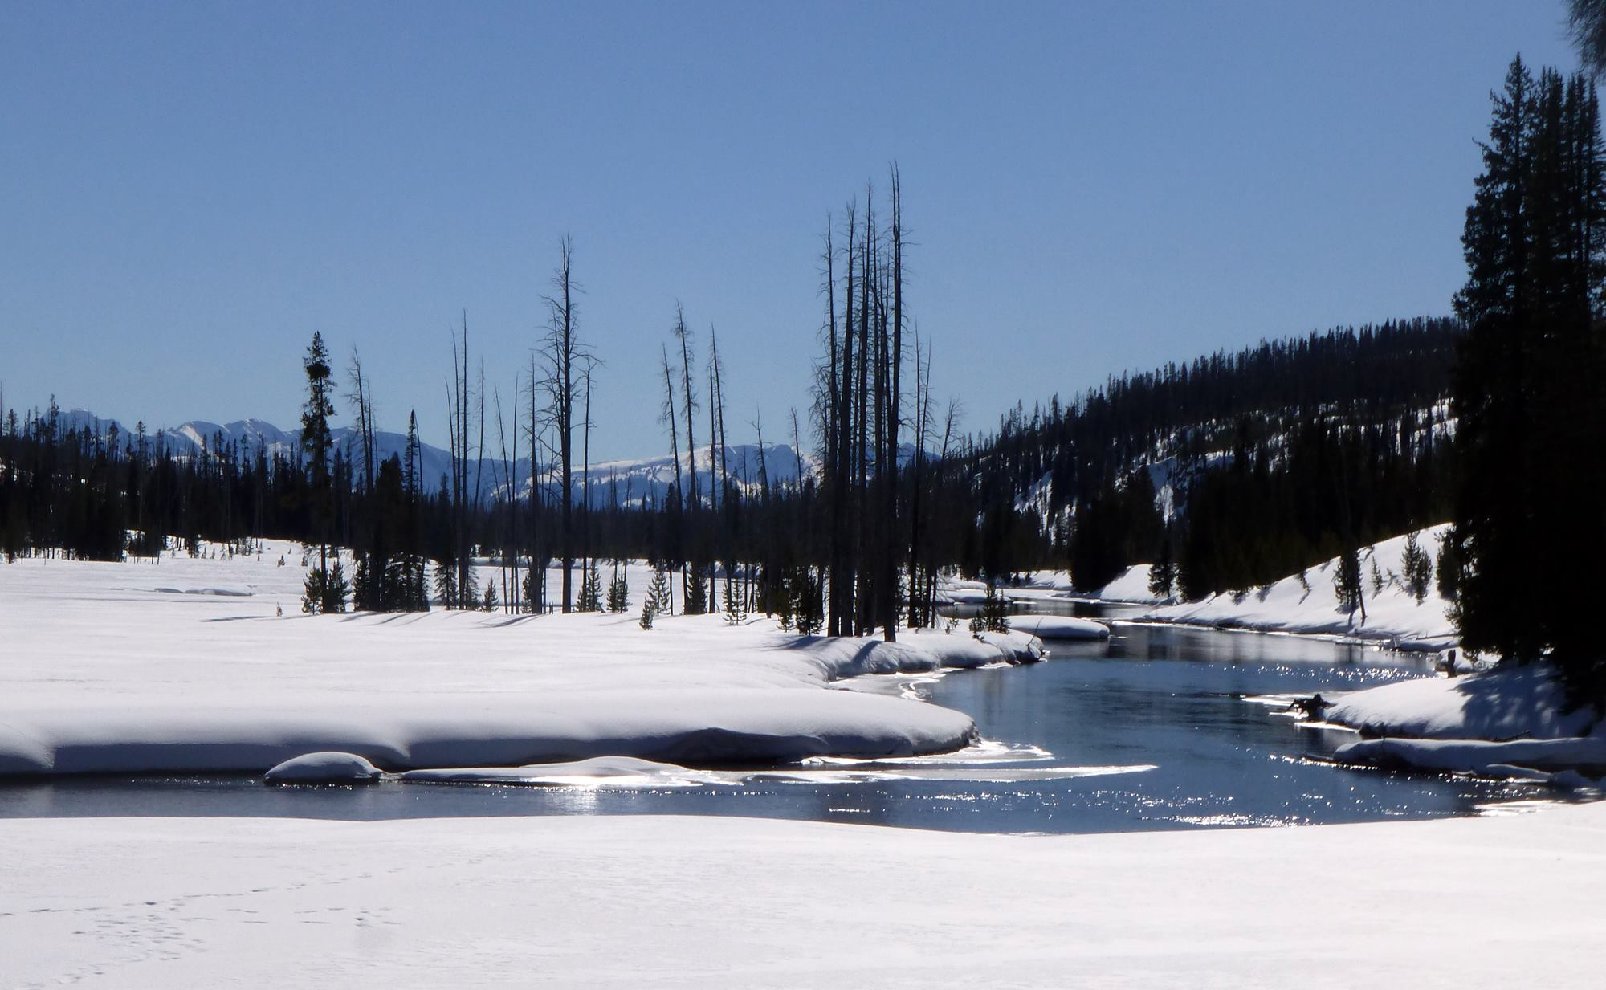
Yellowstone National Park by Jeremy Paul
Under the generic heading ‘Travels of a Wildlife Artist’, Jeremy had brought two contrasting presentations to share with us, featuring opposite ends to the climatic spectrum. The first covered a February 2015 visit to the Yellowstone National Park, Wyoming, sitting on one of the world's largest calderas, where he and other intrepid photographers, led by an expert guide, had to endure temperatures as low as -23 degrees! Here we saw images of elk, moose, American bison, antelope, otters, red foxes, beavers, bald eagles, and trumpeter swans, the largest waterfowl species native to North America. We even glimpsed elusive gray wolves, hunting in packs, and their smaller cousin, the coyote. Through the images, we were able to appreciate the quality of the amazing natural light in the Park and also witnessed the strange phenomenon of snowing from the ground upwards!
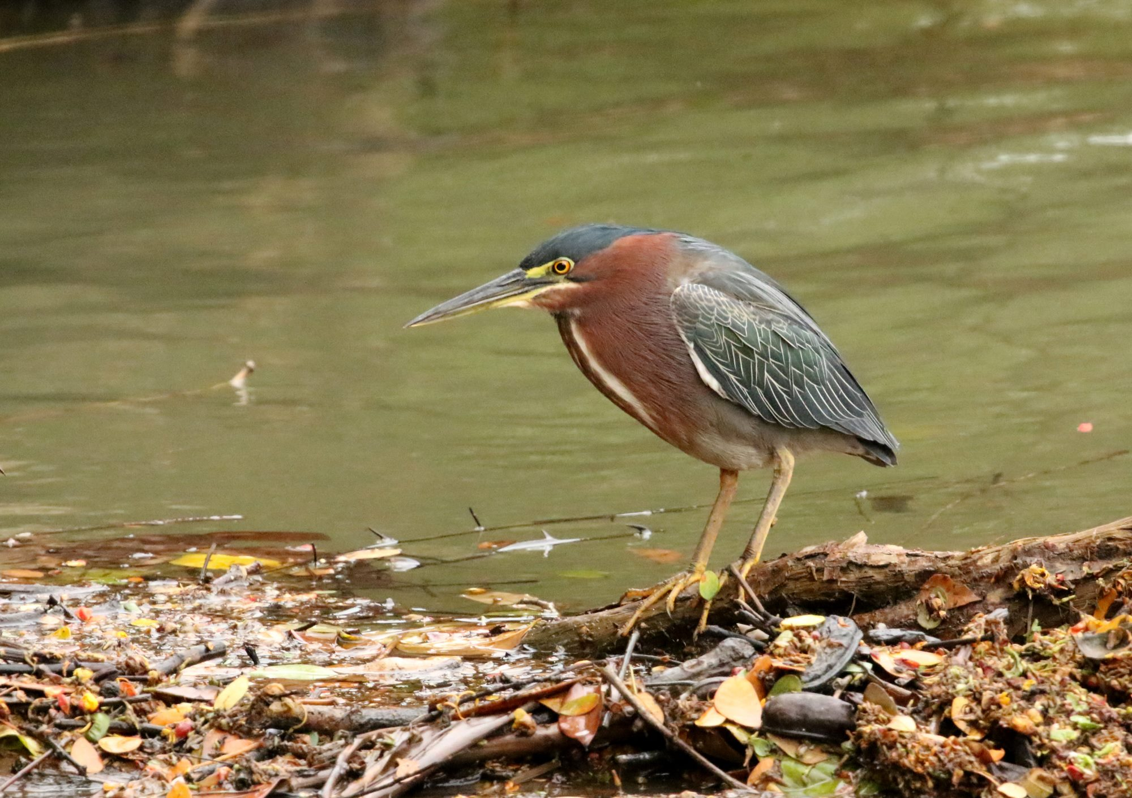
Green Heron, Costa-Rica by Jeremy Paul
The second presentation was from a February 2016 visit to tropical Costa Rica in Central America. This republic is 40% national park where it was over 30 degrees in the rain forest! This country is home to a rich variety of animals and over 800 species of birds. Jeremy showed images which included capuchin monkeys, the two and three-toed sloth, and venomous snakes. We viewed the Cloud Forest Reserve, the Arenal volcano and Lake, and the more remote Osa Peninsula. As expected, the pictures of brightly coloured birds, reptiles and other animals were superb, in spite of the canopy shade and high humidity!
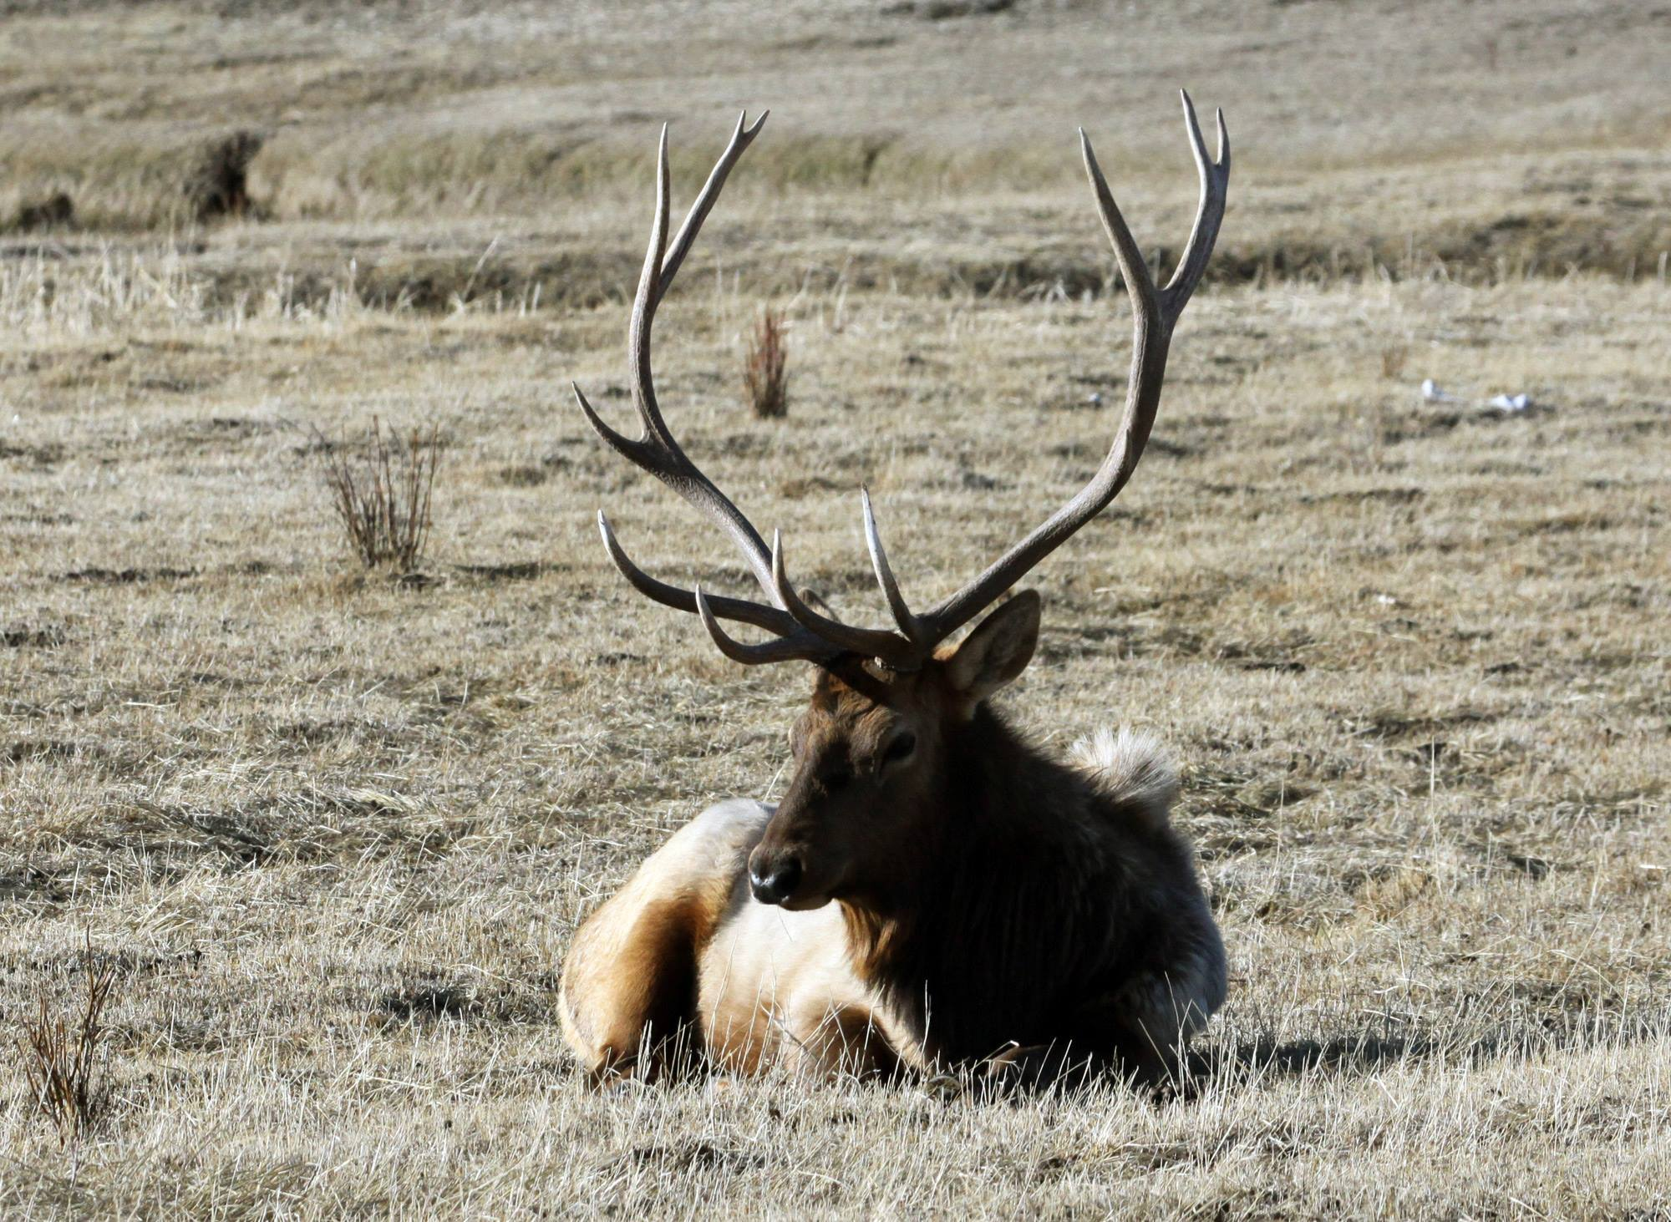
Elk, Yellowstone National Park by Jeremy Paul
Both presentations managed to create an atmosphere which conveyed to his highly appreciative audience a feel for the wildlife in its natural habitat and the Society thanked him with a donation towards the work of the David Shepherd Foundation, which he supports.
The next meeting will be on Wednesday, Wednesday, 22nd February at 7.30 pm when we have an Open Digital Competition. Guests are always most welcome on payment of a nominal charge.
By Antony Hamilton

14th February 2017 - Opening of the IOMPS Exhibition at the Hodgson Loom Gallery
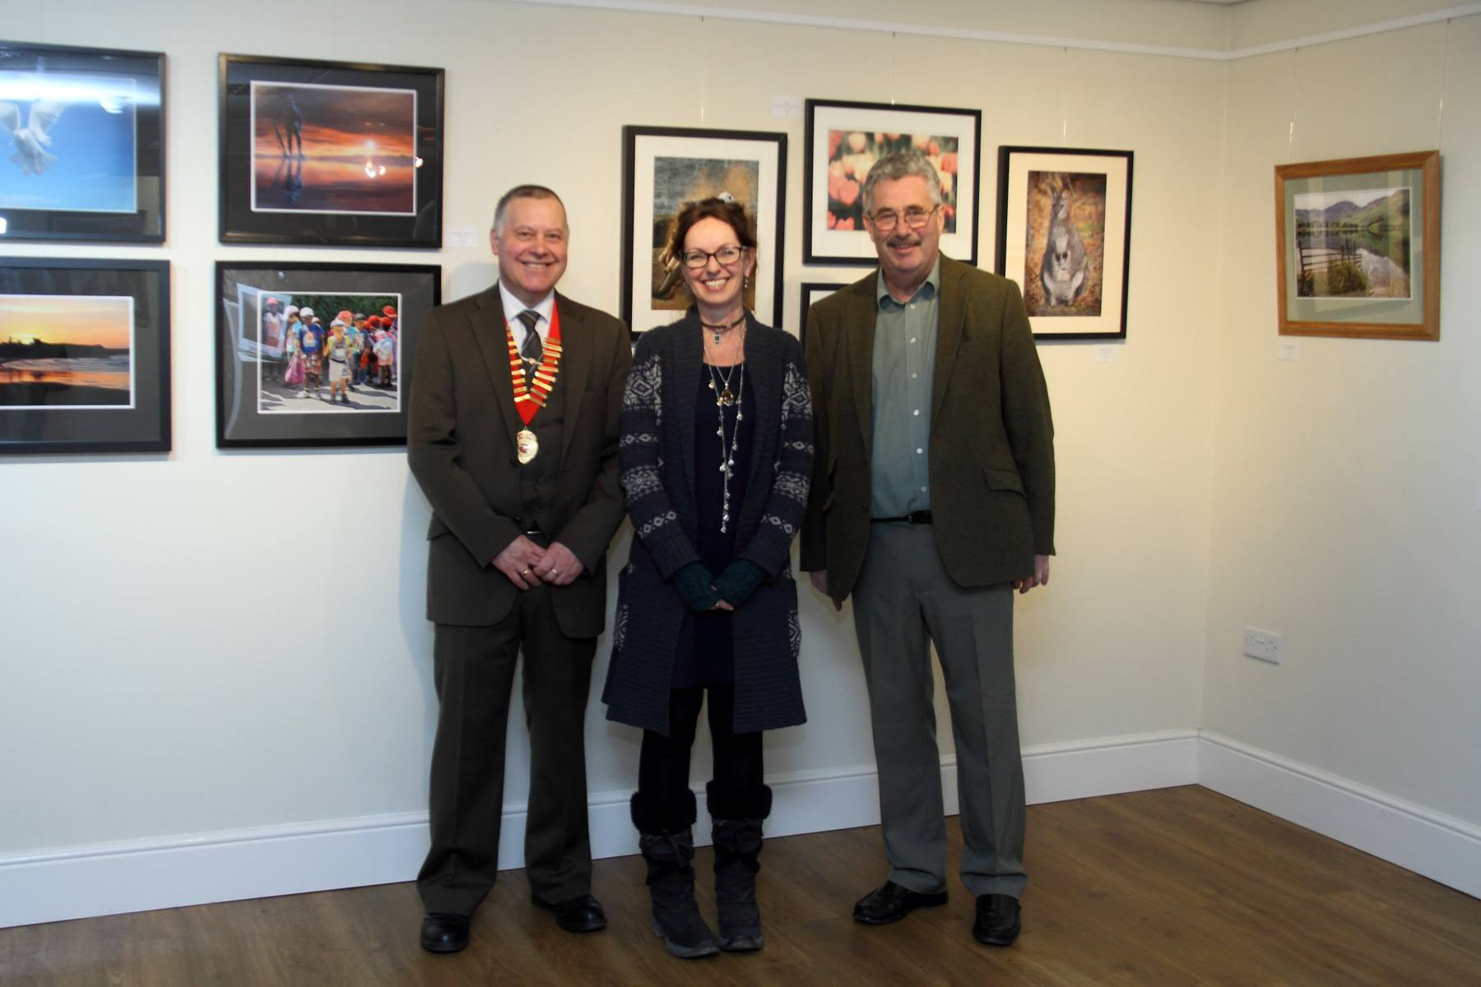
IOMPS President Tony Curtis, Hodgson Loom Gallery Curator Julia Ashby-Smyth and the Hon Steve Rodan at the opening of the Exhibition
In a very well attended ceremony, the latest annual exhibition of works by members of the IOM Photographic Society was officially opened on 11th February at the Hodgson Loom Gallery in the Laxey Woollen Mills. Introduced and welcomed by Club President Tony Curtis, the Hon Steve Rodan, President of Tynwald and Member of the Legislative Council, opened the exhibition, paying tribute in his remarks to the e...xcellence of the images and congratulating the authors for the skill and talent being displayed. The exhibition comprises more than 80 prints, mostly in a framed A3 format, and covering a range of genres including natural history, landscapes and creative. Most of the images are for sale, and all at a very reasonable cost.
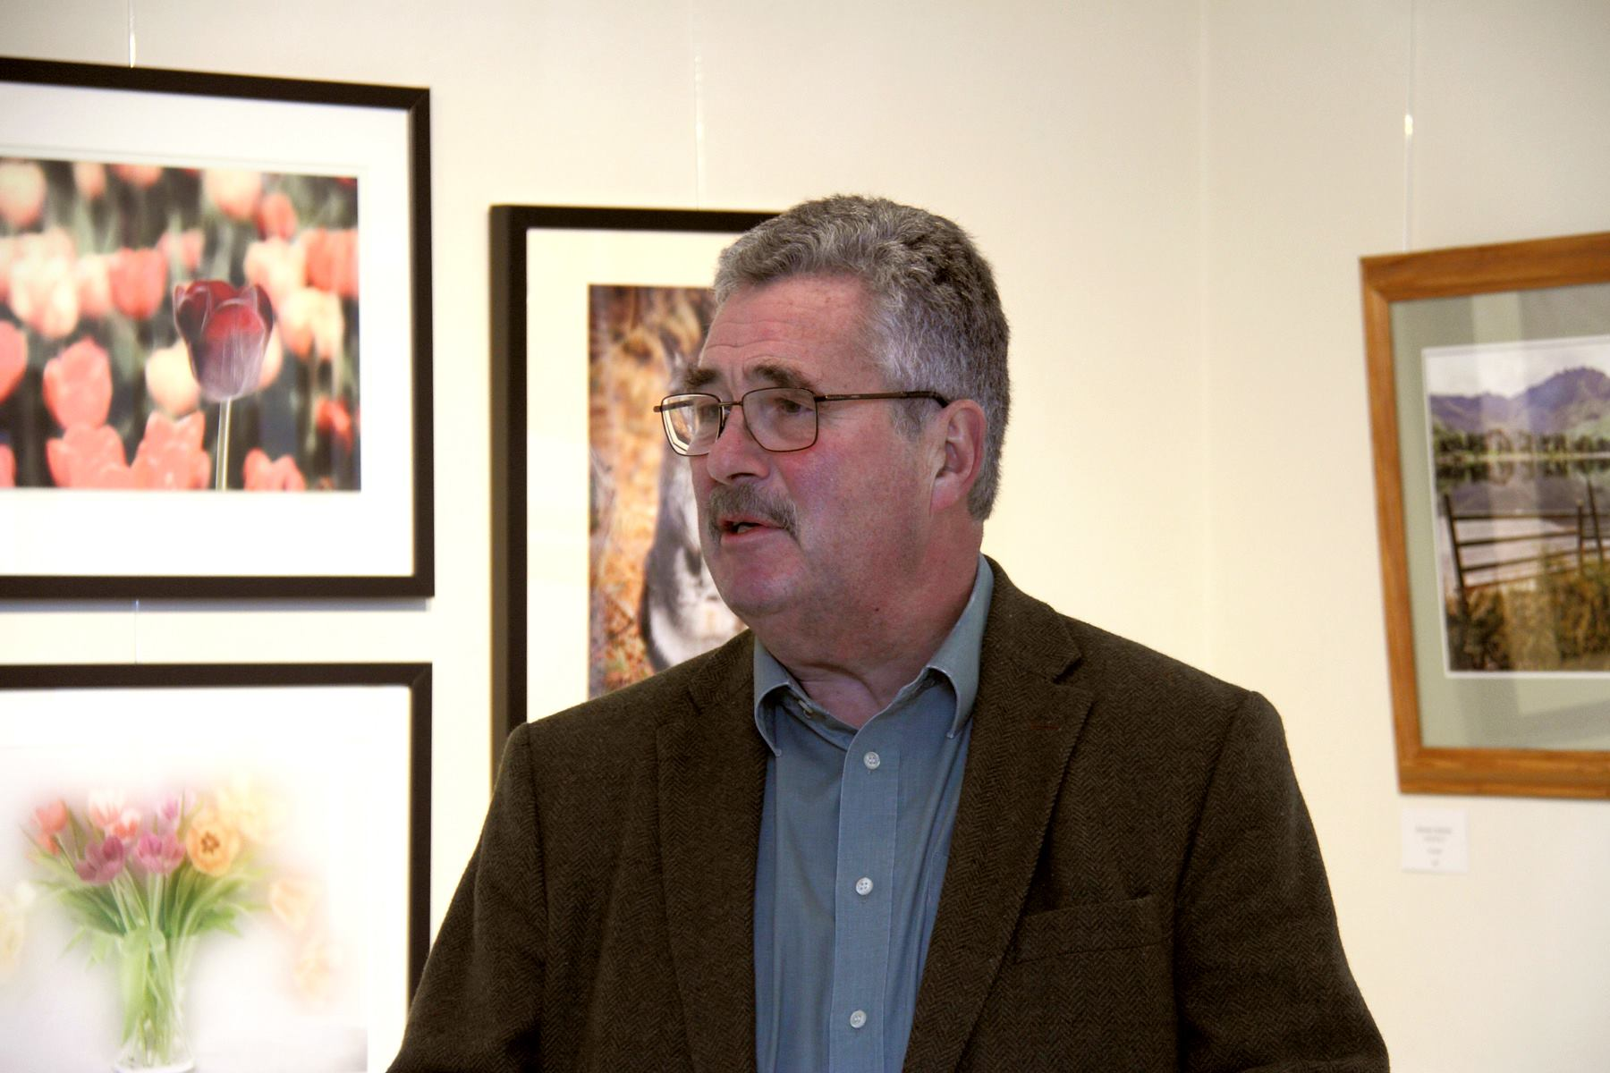
The Hon Steve Rodan opening the Exhibition
The gallery makes an excellent venue for an exhibition, with a mix of natural light and cunningly placed spotlighting, whilst the open layout encourages viewing of the prints at both distance and close up. Julia Ashby-Smyth, as curator for the gallery, has as always done an excellent job of arranging the display. The gallery is open from 9am until 5pm, Mondays through Saturdays, and the exhibition runs until Saturday 11th March, with entry free of charge. A visit to the gallery will prove a rewarding artistic experience and well worth while – visitors will be intrigued and stimulated by the quality of photography in the exhibition, and perhaps inspired to “have a go” themselves!

6th February 2017 - IOMPS Exhibition at The Hodgson Loom Gallery
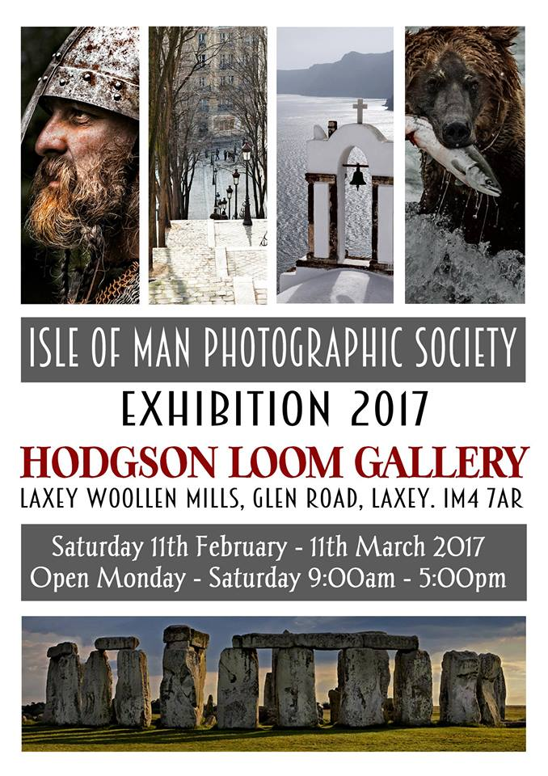
The Hodgson Loom Gallery at the Laxey Woollen Mills will be home to a selling exhibition by members of the IOM Photographic Society, open to the public from Saturday 11th February until Saturday, 11th March. The Gallery provides a superb display area – warm, intimate, and with excellent lighting –and as always, it will be carefully curated by Julia Ashby-Smyth, allowing the works to be shown to maximum advantage. The IOMPS is delighted to have the opportunity for the exhibi...tion which is now in its sixth year at the gallery.
The exhibition will include both a wide range of subject matter (e.g.travel, portraits, natural history, landscape, and architecture) and features the work of a wide number of members of the society – some only recent recruits, some long-term contributors to the society. Amongst the better known names of those exhibiting will be three of the society’s “life members”:
Dr Ruth Nicholls LRPS DPAGB BPE3* EFIAP – has had her work accepted at numerous exhibitions both nationally and internationally, her landscapes and floral studies in particular of the highest quality
Ron Shimmin LRPS – a long-time member with an enviable record for producing highly artistic images with a meticulous attention to detail, whether architectural shots or street reportage
Sue Jones CPAGB – another long-time member, now a full-time professional working with Andrew Barton LBIPP LMPA, and who produces top quality images in a wide range of genres
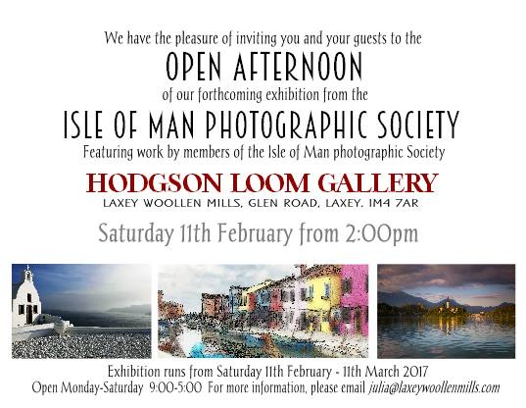
A total of eighteen members of the society are included as exhibitors, each showing some of the best of their work, and all contributing to what will be an exceptional display of photographic talent, and making a visit to Laxey well worth while.
The Society currently meets on Wednesday evenings during a season running from late September through to April at the Art Society Building (Thie Ellyn) in Withington Road, Douglas, with all meetings starting at 7:30pm. The summer break usually includes a series of outings and workshops allowing members additional opportunities to socialise and to develop their photographic skills. Meetings are open to the public, and all will be given a very warm welcome.

3rd February 2017 - Andrew Barton Photographic Workshop
Andrew Barton Full Day Studio Photographic Workshop to be held on Saturday 11th February 2017.
Places limited to a maximum of 15.
Call 817817 to book your place.
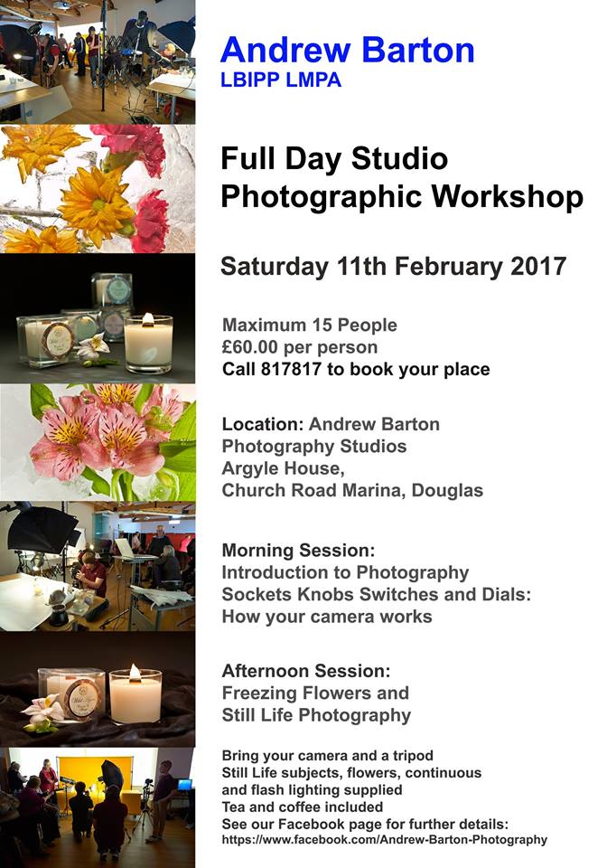

2nd February 2017 - Second ‘Critique’ Session of the Season
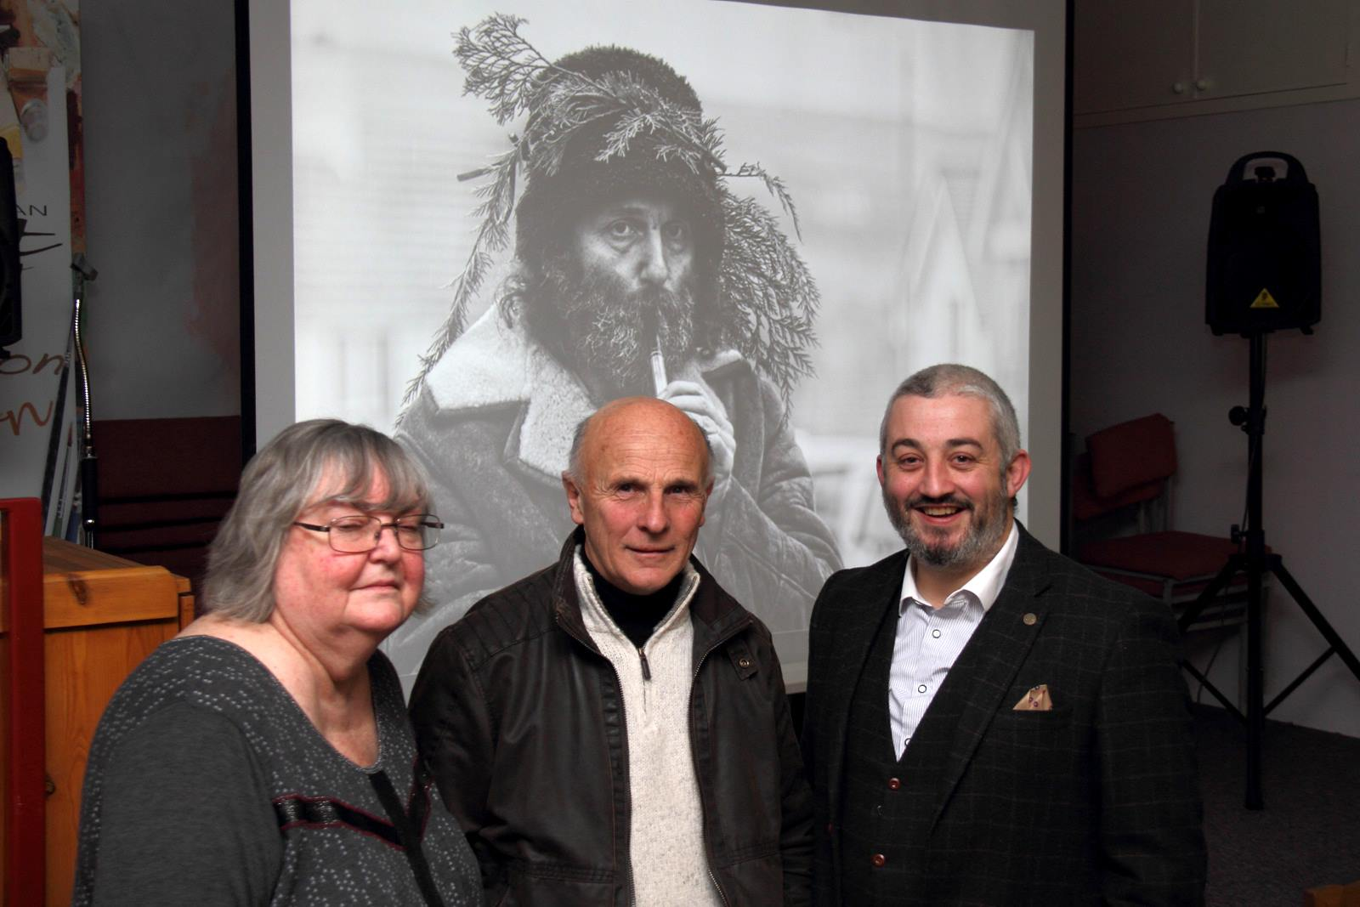
The three ‘critique’ session judges: Patricia Tutt, Ray Kelly and Steve Babb
On Wednesday 25th January the Isle of Man Photographic Society held its second ‘critique’ session of the season. On this occasion the society were fortunate to have the assistance of three of the Islands judges – Steve Babb, Patricia Tutt and Ray Kelly.
In traditional terms ‘critique’ means ‘a detailed analysis or assessment’ and this was certainly provided. It was a fantastic opportunity for members to gain an insight into the judging process and to hear the judges discuss ...different aspects of the images. Steve Babb had also kindly provided alternative edits of the images to demonstrate the different effects that adjustments in brightness, contrast, or colour could create.
Members had submitted images for the judges to evaluate and the three judges took it in turn to discuss the merits of the images and suggest ways in which they could be improved – including cropping, editing, colour balance, brightness and contrast and change of viewpoint. With no scores involved it was a great informal way for members to test out images and receive feedback on them.
Next Wednesday 8th February the society will host ‘Travels of a Wildlife Artist’ – a presentation by Dr Jeremy Paul. This is always a highlight of the season and visitors are welcome – indeed you are encouraged to arrive early to get a good seat! The talk will begin at 7.30pm at Thie Ellyn.
The following Saturday sees the official opening of the society’s annual exhibition at the Hodgson Loom Gallery in Laxey at 2pm, again all welcome to view this display of members work with many images available to purchase.
By Hazel Walsh

IOMPS Reports During March 2017

30th March 2017 - IOMPS wins battle against Oldham Photographic Society and Rochdale & District Camera Club
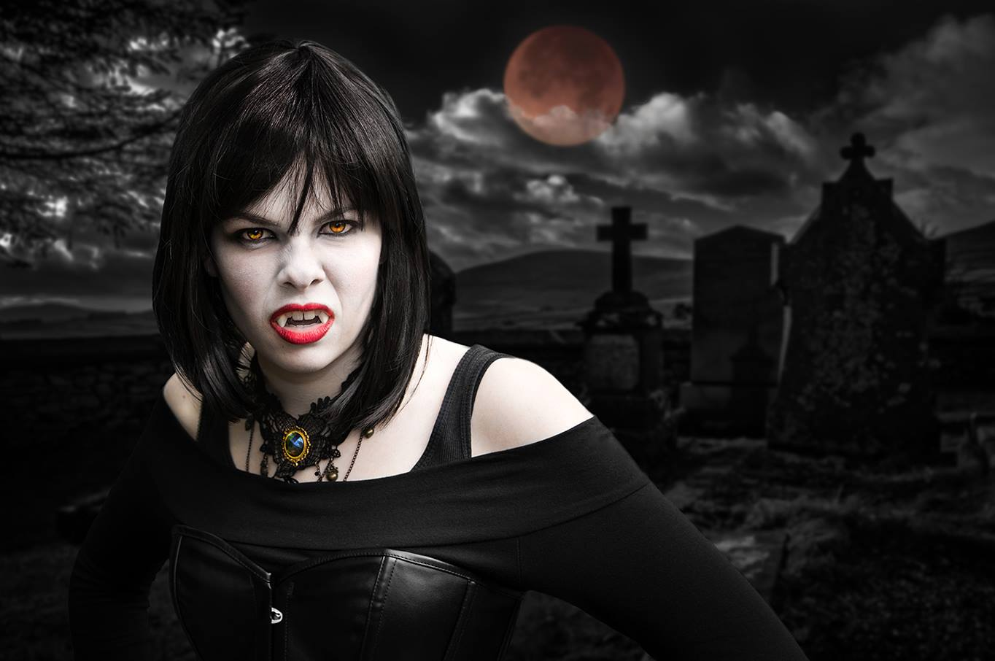
One of the images which scored the maximum of twenty points in the IOMPS v Rochdale v Oldham battle was "Blood Moon" by Sue Jones
For the past five years The Isle of Man Photographic Society has competed in a three way battle with the Photographic Societies of Oldham and Rochdale. Each Club submits 25 of their best digital images for this competition. President Tony Curtis introduced the battle and explained that although the images had been judged earlier in Oldham, the video of the event had been received only a... few hours before the meeting, so nobody had seen them or knew the result.
We were in for an extremely good evening's viewing of the best photographs submitted by photographers of the IOMPS, RDCC (Rochdale) and OPS (Oldham). The judge, Keith Barber, first told us that he rated images that had the greater impact more highly than others which, although technically excellent, did not have such immediate impact. We viewed all seventy five images with the judge' comments and 24 of them were rated as "excellent" and were then held back for the highest marks. When the best 24 were finally reviewed the Isle of Man had some notable successes. 11 of the photographs that scored 18 points or more (out of a maximum of 20) were from the Isle of Man. The following images scored 19 points for the IOMPS:
"The going down of the sun" and "Brown bear with salmon at Katmai" by Chris Blyth
"In Another Place" by Nigel Owen
"Last Catch" by Sue Blythe
"Painted Lady" by Sue Leeming
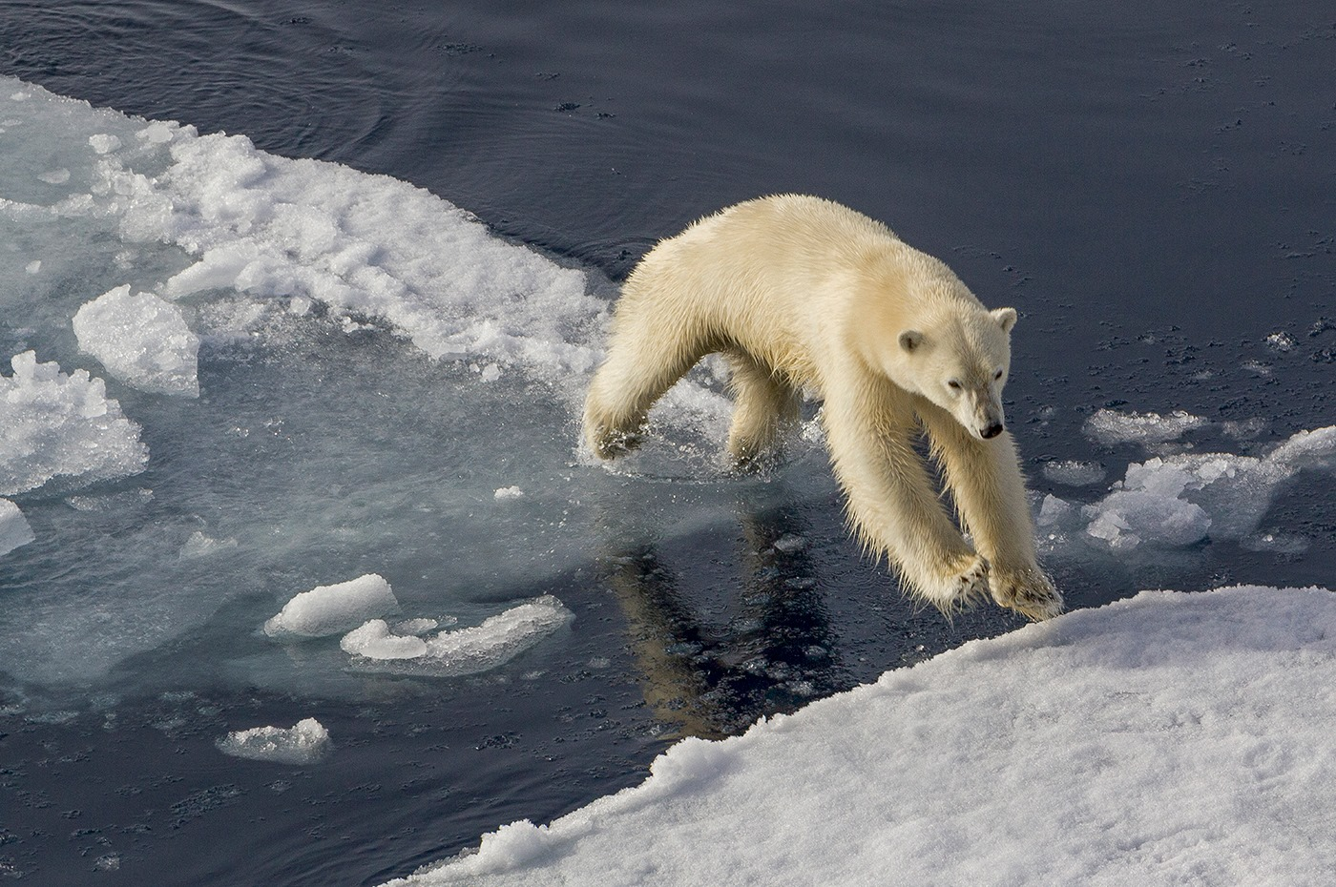
Another images which scored the maximum of twenty points was "The Leap" by Sue Blythe
Three of these, the best images, were awarded the maximum 20 points. These were:
"Blood Moon" portrait of a vampire, by Sue Jones
"The Leap" a leaping polar bear, by Sue Blythe
"The Bone Collector" a sinister individual, by Hazel Walsh
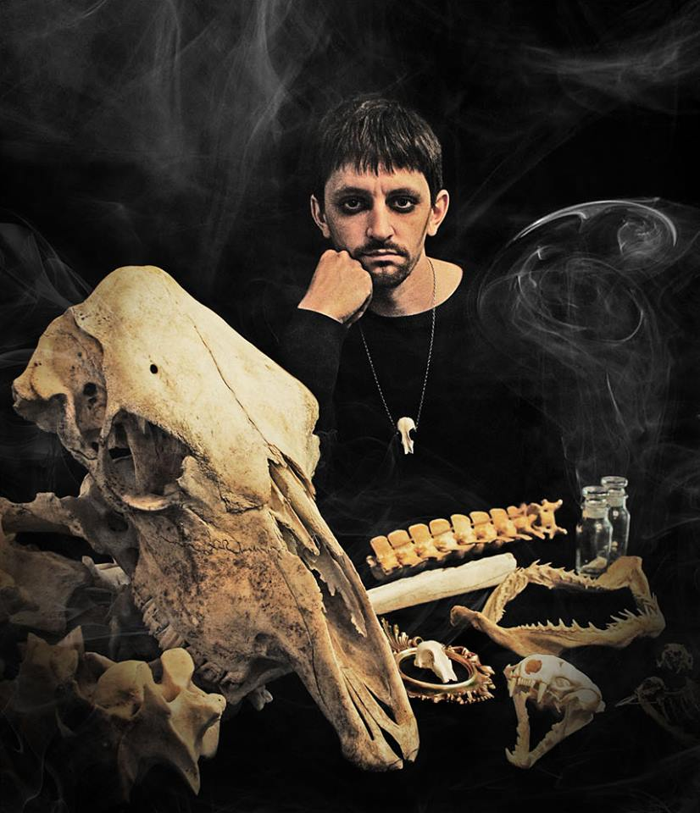
"The Bone Collector" by Hazel Walsh also scored twenty points in the IOMPS v Rochdale v Oldham battle
Because so many of our images scored highly the IOMPS won the competition by a margin of 5 points, the final scores being:
Isle of Man Photographic Society: 424
Oldham Photographic Society: 419
Rochdale and District Camera Club: 373
There will be no meeting on Wednesday 5th April as the Annual Competition will be judged on Thursday 6th and Friday 7th.
Meetings begin at 7.30pm at Thie Ellyn, off Withington Road, Douglas and are open to the public with a nominal charge for non members. New members and guests are always welcome.
By Richard Shafto

16th March 2017 - Chris’s fun and informative talk about Manx Curiosities
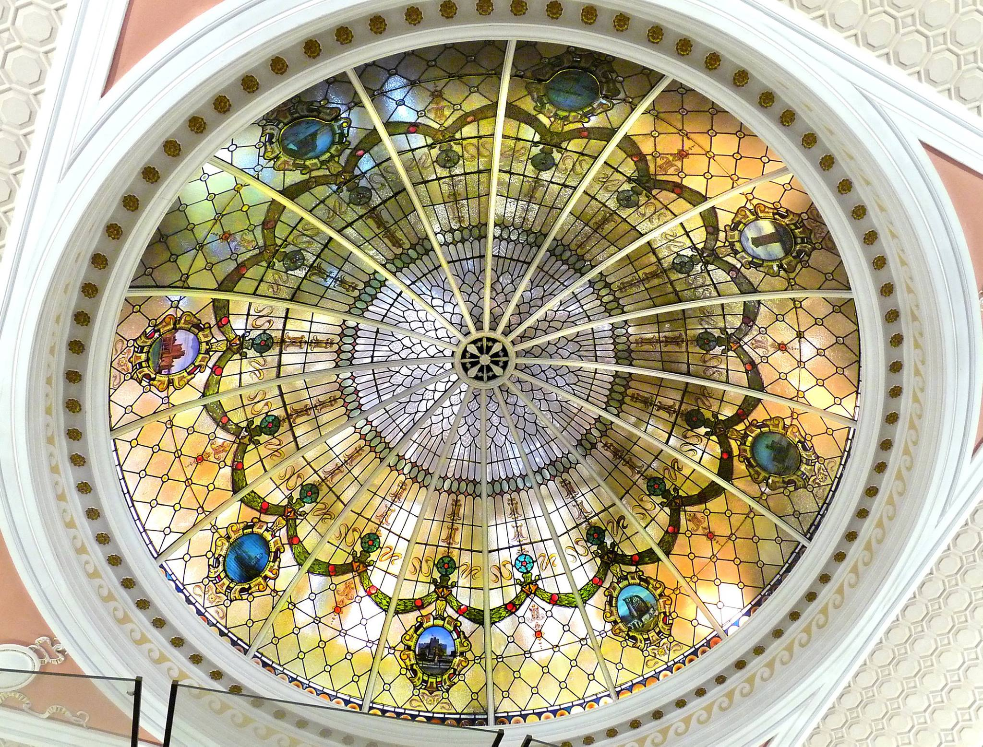
Isle of Man Bank ceiling detail by Chris Nicholls from his Manx Curiosities presentation and quiz
It was another great night at the Club with an interesting and humorous presentation and quiz entitled Manx Curiosities by Chris Nicholls. The quiz involved identifying photos Chris had taken around the Island and he provided some interesting information about each caption along with the answers. One of the earliest images was of the three legs of Man at Nobles hospital. Not only did we have to know where the image was t...aken but also whether the legs were facing the correct way or not. This proved to be quite controversial and much debate ensued with the members debating the correct direct. Eventually we all came to an agreement, rightly or wrongly, that the legs should be running towards Ireland and away from England.
Another question of the night was who are the 6 Celtic nations? The majority of the members managed to note Scotland, Wales, Ireland, the Isle of Man of course but struggled with the last two, which of course are Brittany and Cornwall. Other fascinating facts came out through the night such as the name for the standing stone in Douglas - the white lady; the whipping stone in Onchan for tying witches to before whipping them; the rocket house in Castletown named for using rockets with ropes attached to fire across the harbour to stricken vessels in need of rescue to enable pulling them ashore; and many more curiosities.
Chris produced some beautiful images including three photographs of old decorative ceilings with members having to guess their locations. They were of the Isle of Man Bank, the Gaiety theatre and the Villa Marina. Reminding us all to look up the next time we go to a show or event.
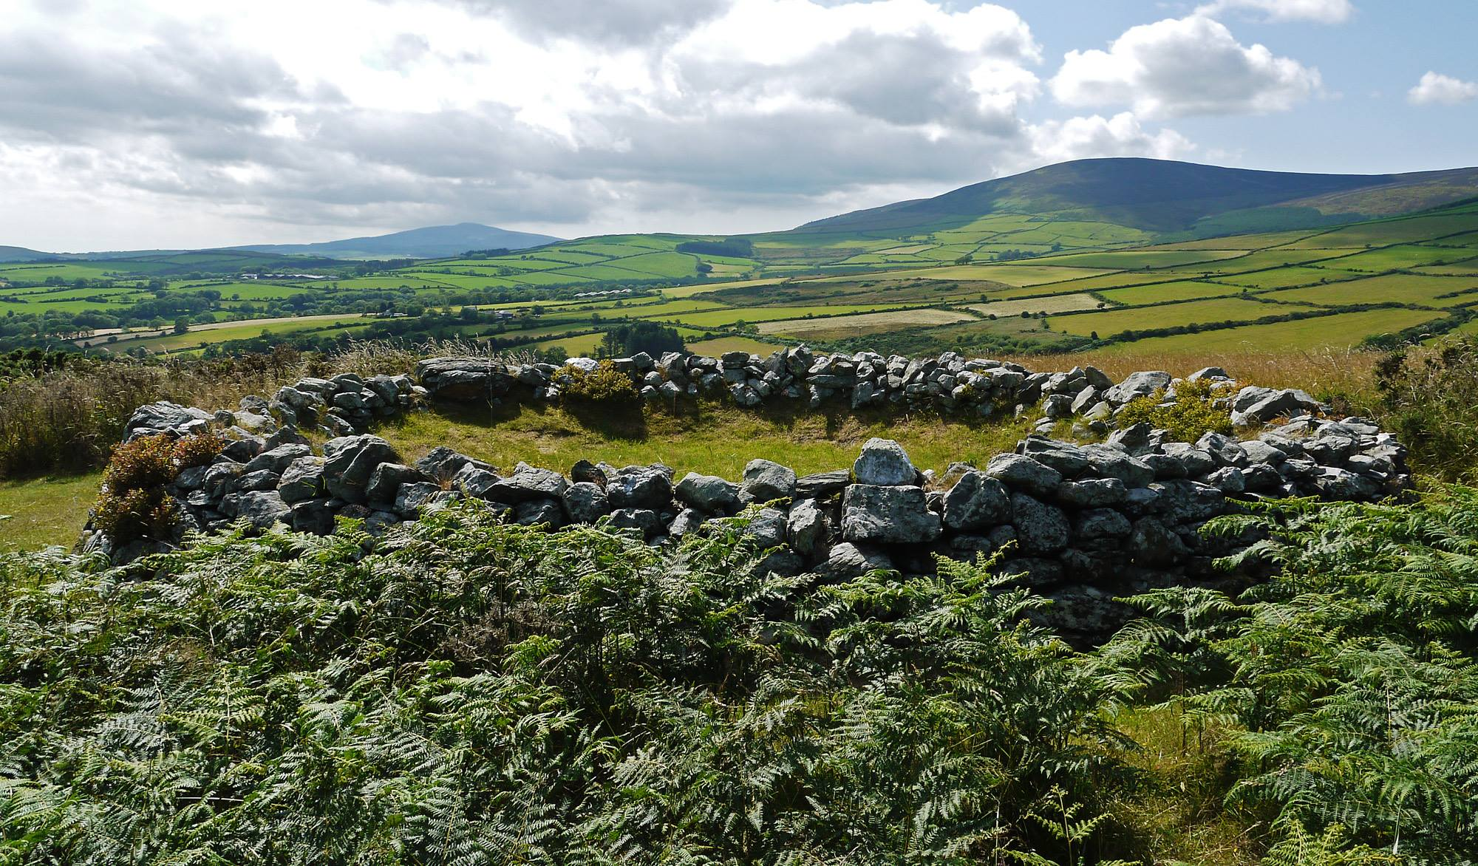
Site of the old Tynwald by Chris Nicholls
A vote of thanks was given by the Chairman Tony for Chris’s interesting and fun quiz. Clearly a lot of effort had gone into producing the quiz and the photographs were of course of high standard.
After the tea break and more discussions about the quiz the members were treated to a L&CPU Portfolio. This gives members a great opportunity to see the standard of other clubs from the north west of England and maybe great some ideas and inspiration. The standard of images is always high and this portfolio was no different. There was such a mix of images from natural history to landscapes and portraits. A great collection that all the members enjoyed. The winning image was a beautiful heard of wild Wilder beast on their migration. A deserving winner.
By Lara Howe

9th March 2017 - An Evening with Charles Guard and IOMPS President Tony Curtis
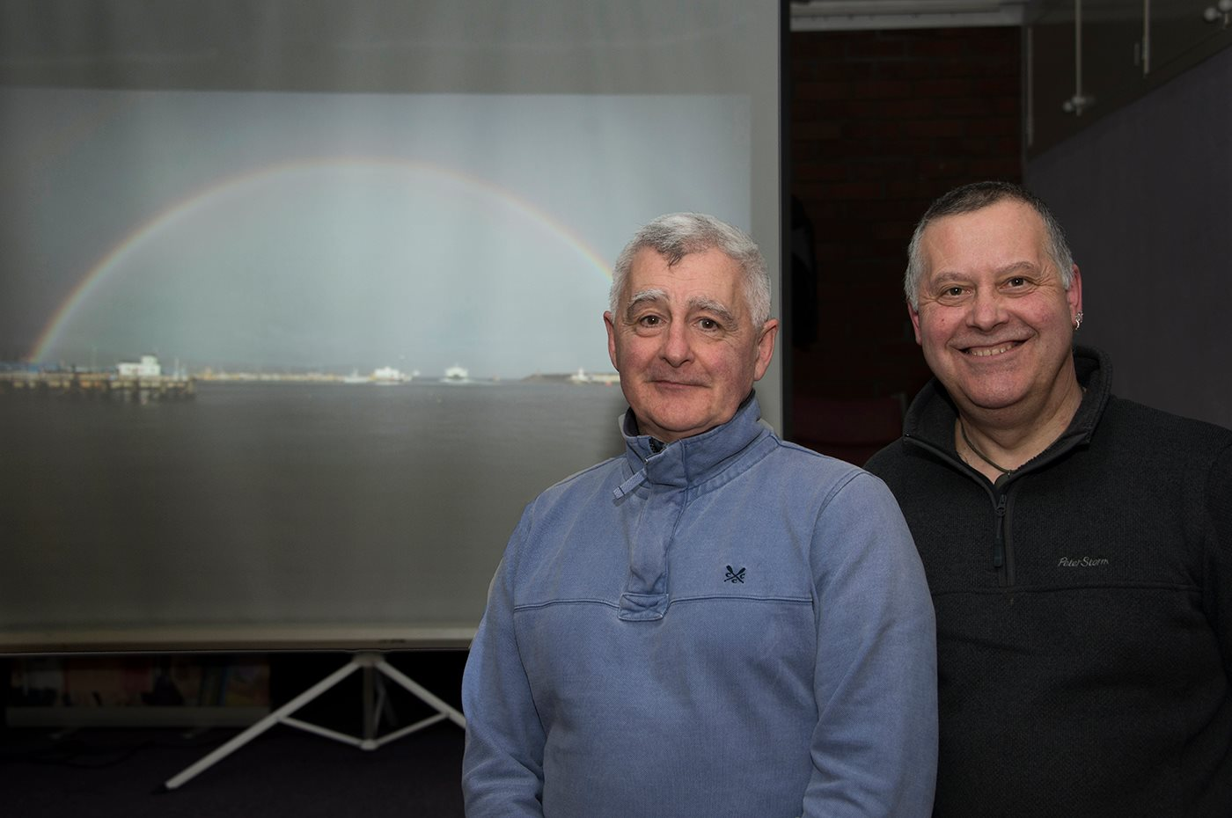
Charles Guard and IOMPS President Tony Curtis
The latest meeting of the IOM Photographic Society proved to be a most enjoyable and very relaxing evening. The first half of the evening comprised a presentation by Charles Guard – an eloquent and accomplished speaker, and as became very evident during the evening, a man of many talents – music composer, film producer, editor and presenter, for example, and all done with apparent effortless ease. The second half ...saw our Club President, Tony Curtis, showing a range of images taken over the past several years and displaying his talent as a photographer.
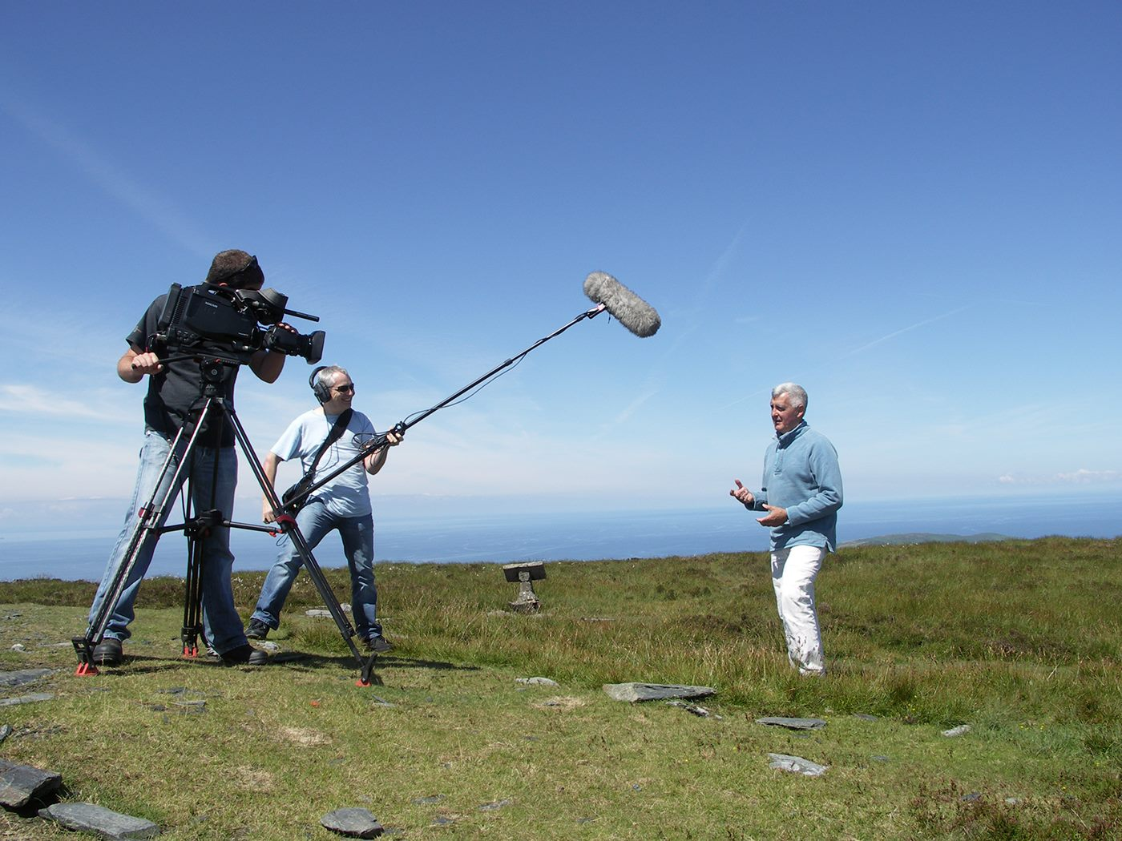
Charles Guard gave a fascinating and entertaining evening with his presentation on thirty years of filming documentaries both on and off the Isle of Man
Charles’s presentation was essentially though not exclusively around “Filming Of The IOM” – and he has a wealth of experience of his subject, having been involved since the late 1960’s in producing and presenting films and videos for both the government and for the private sector, many of which are available to this day. But the presentation wasn’t just about the films, interesting and fascinating as they are. The story was often more about the background to the films, usually delivered with some amusing anecdotes – of the actors and their quirks, the shooting of the scenes, the difficulties and costs in making the films, equipment or features on the island now disappeared, the “happenings” which did not (and often could not) appear in the subsequent film. Meantime, as technology has developed, the equipment used has changed dramatically – from the heavyweight film cameras to the lightweight OSMO 4K quality videos camera today, and to the drones now being used for aerial shots and a very different viewpoint – but again all demonstrated with real technical expertise and knowledge. Tony Curtis gave a well-deserved vote of thanks for a very polished performance!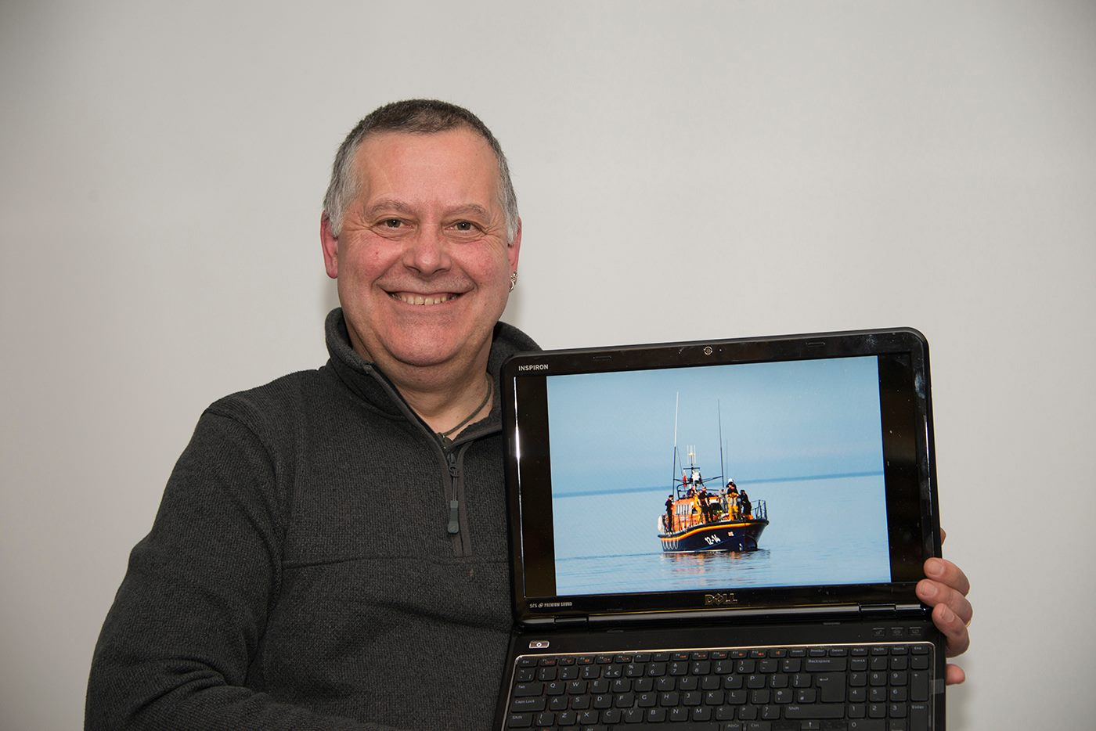
IOMPS President Tony Curtis with one of the images from his presentation
A very difficult act to follow, but Tony then finished a most enjoyable evening with a display of digital images to demonstrate his photo skills, together with his commentary explaining the reasons for taking the shot. These covered a wide range, but highlights included shots of the Ramsey Lifeboat, a superb shot of a full crescent rainbow over Douglas Bay, some TT motorbike images, the moon, storm waves over the Fenella beach in Peel, and an entrancing shot of the tree reflections in the Injebreck reservoir. All in all, an excellent evening greatly enjoyed by our audience.
Our next meeting, on 15th March will be a print competition for the IOM Bank Cup – one b&w image and one colour image per competitor – on the set subject of “Something Manx”. Details of the IOMPS programme can be found on the website www.iomps.com. Meetings are held at Thie Ellyn (the Art Society building) in Withington Road, Douglas every Wednesday during the season starting at 7:30 pm, with all meetings open to the public (with a modest charge) and all – whether photography beginners or more experienced - will be made very welcome.
By Chris Blyth

2nd March 2017 - February 'Open' Digital Competition
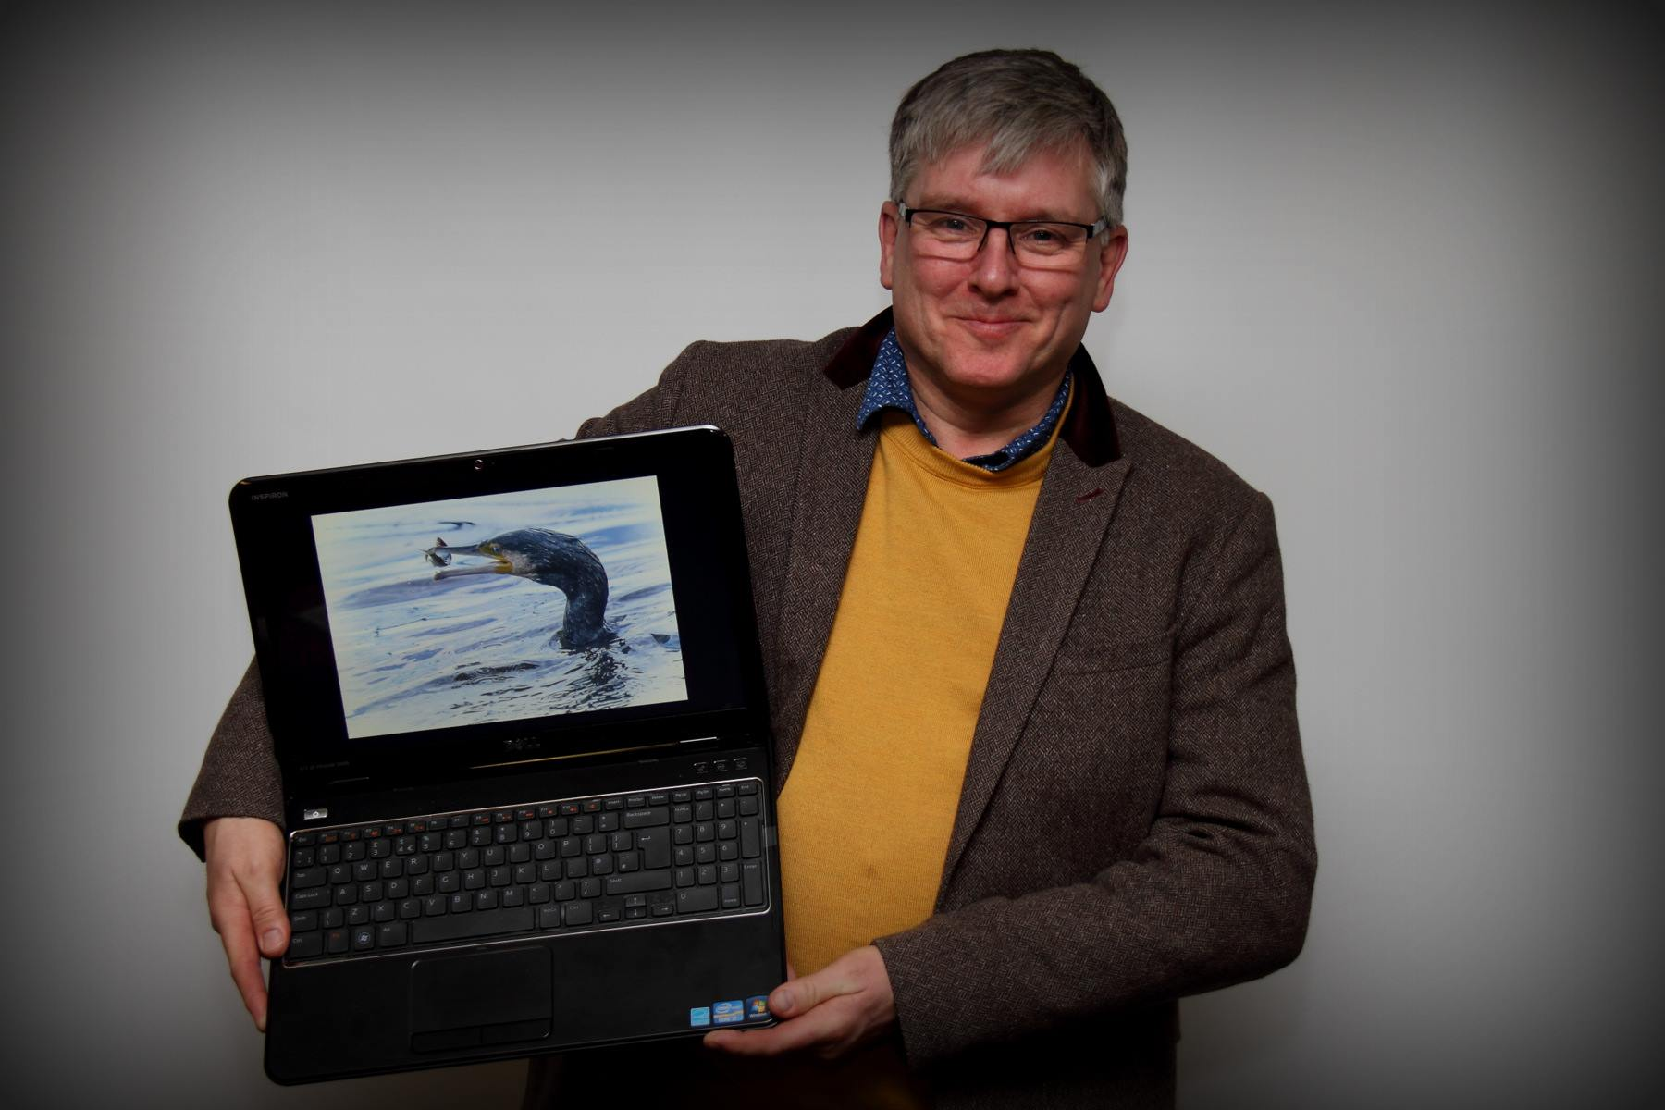
February 'Open' Digital Competition Judge David Killip
The judge for our February 'Open' Digital Competition was a past IOMPS member David Killip.
When judging the images David had not found an obvious graduation of quality between the Standard, Intermediate and Advanced groups. There were excellent images in all three sections. In fact David found a lot of good points in every image and occasionally suggested ways in which he thought each image could be improved.
In the Standard Group Peter Keena took third place with "Log Chapel in the Rockies", which conveyed the atmosphere and feel of the subject in vivid colour. Richard Leech claimed second place with "Poppies", a well composed shot of the display at the Tower of London in 2016. The winner of this section was Peter Keena with a photograph of (possibly) the roughest sea on the Island entitled "Towering wave" crashing over a breakwater.
The images submitted by the Intermediate Group also came in for more praise from our judge. David was a great lover of monochrome photographs and he especially liked the "Landing Stage", a fine landscape with much fine detail by Shirley Lotfy, which he placed third. Second place went to "Into the Surf" by Barry Murphy a spectacular view looking into the setting sun across a rough sea with the sunset reflected in the wet sand. First place also went to Barry Murphy for "Forever Together" a strong image of two puffins, with no distractions in the background.
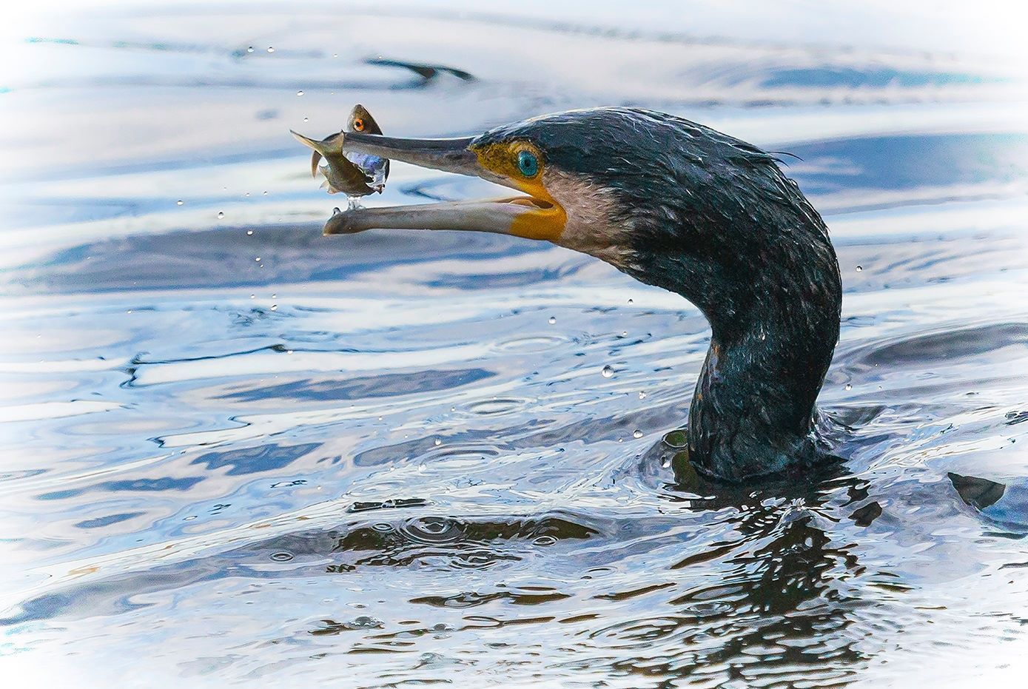
Best Image in the Competition went to 'Slippery Catch' by Sue Blythe
As expected the Advanced Group provided some extremely good photographs. Third place went to "Lavender and Grass" by Chris Nicholls. This was a beautiful image that looked like an oil painting. Although simple it had huge pictorial qualities. Second was "Stripes" by Chris Blyth, a photograph of several zebras with no background, which of course was all in black and white stripes! The winner "Slippery Catch" by Sue Blythe was a sensational photograph showing the head of a cormorant just after it had caught a fish. Both the fish and head of the cormorant were in perfect focus and the shot had been timed so that although the fish was in the beak of the bird, it was not actually in contact with it. David had no hesitation in giving this image the award for the best photograph of the competition.
Next Wednesday 8th March, will be a presentation on 'Manx Curiosities' by Chris Nicholls and an L&CPU Portfolio beginning at 7.30pm at Thie Ellyn, off Withington Road, Douglas. Meetings are open to the public with a nominal charge for non members. New members and guests are always welcome.
By Richard Shafto

20th April 2017- An Evening of Lighting and Lightroom
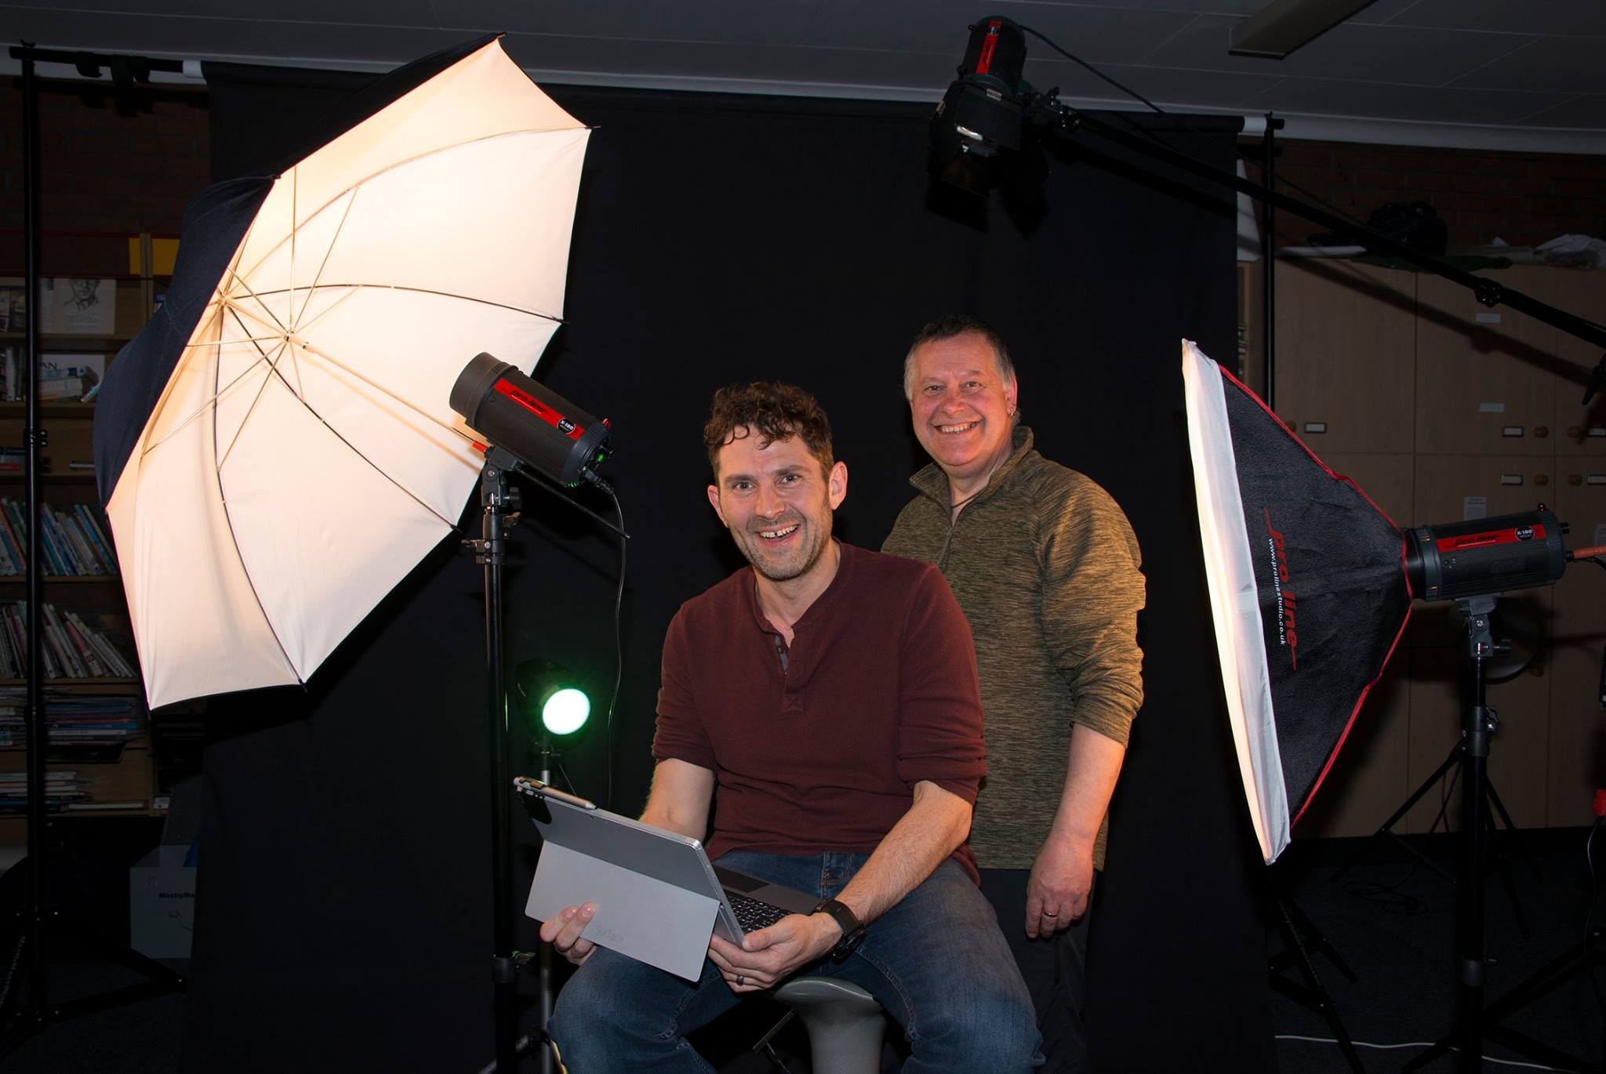
Richard Leach and Tony Curtis who presented the ‘Lighting and Lightroom’ evening
The meeting on Wednesday 12th April was an evening of two parts. The first hour took the form of a studio lighting set up under the guidance of Tony Curtis and the second part of the evening involved processing the images taken using Lightroom which was demonstrated by Richard Leach.
Tony Curtis had converted part of our meeting room to a photographer’s studio with four lights set up in very different positions to demonstrate their effect on the images produced. Tony’s camera was connected directly to a projector, so that all the pictures taken were projected onto a screen and were then immediately visible to everyone. There was continuous discussion with the audience while the photographs were being taken and we all learned something from this practical experience.
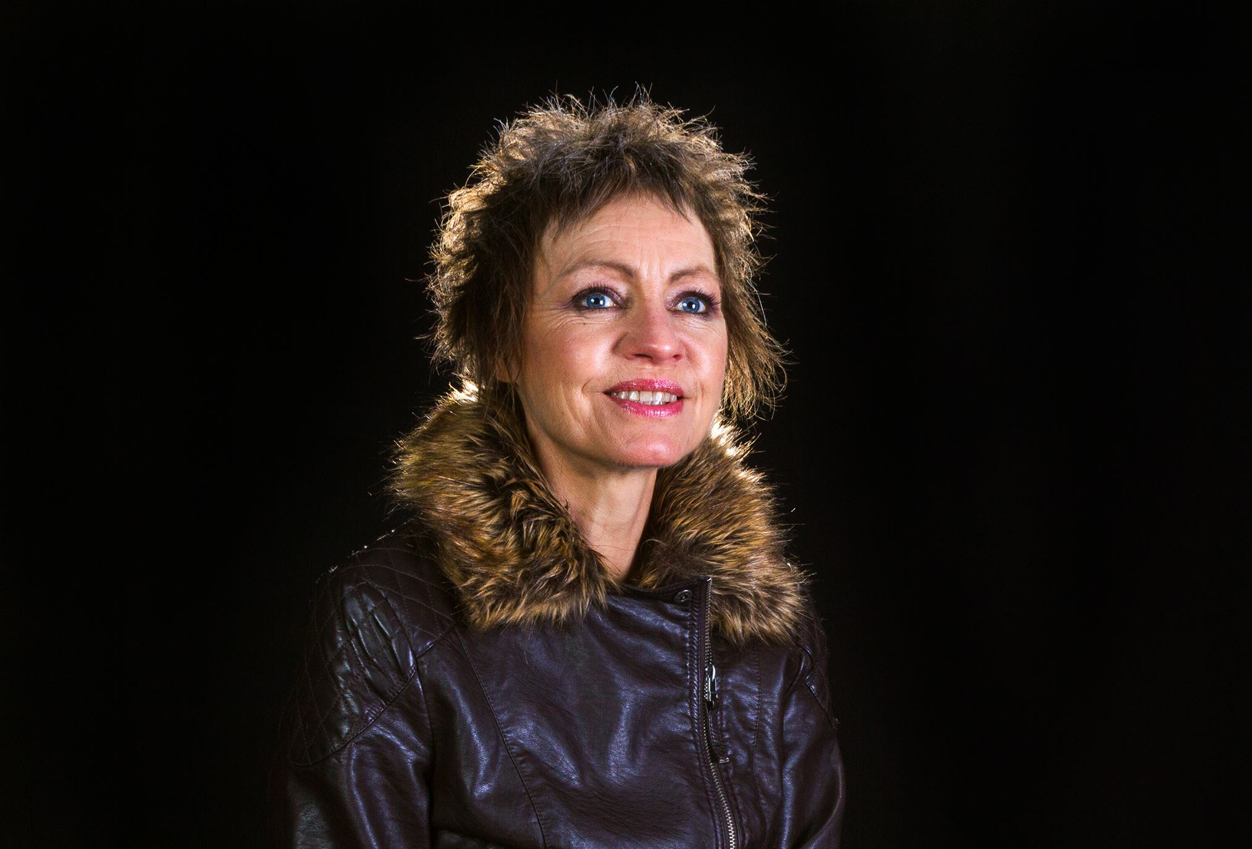
One of the images of model Sue Leeming taken during the ‘Lighting and Lightroom’ evening
The technical aspects of lighting a subject to get the best photograph were demonstrated at length. A basic set up of three light sources was used to begin with: lighting from both left and right sides and from above. The intensity of the lights and their position were all adjusted to show the effect on the image. Getting the model’s hair to look good was resolved by placing a fourth light (a bright spotlight) directly behind the model’s head. Our thanks to member Sue Leeming for being the model for the evening.
Richard Leach then took over for the second part of the meeting and demonstrated some of the many features of Adobe Lightroom to improve the pictures. For example, it was quite easy to make the background completely black and eliminate areas which were in fact shades of grey. All the processing steps carried out by Richard were made clearly visible to the audience by using the projector that had earlier been connected to Tony’s camera for the studio session.
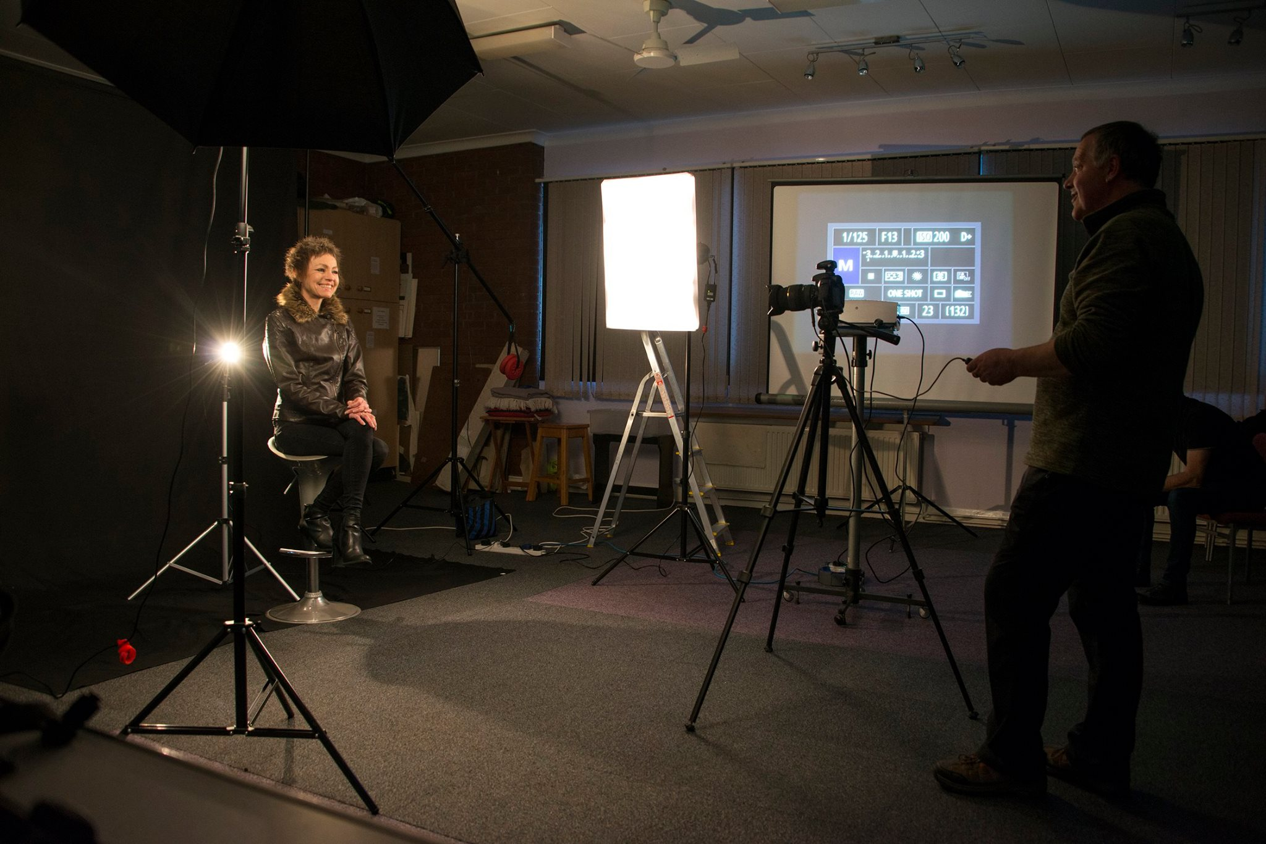
The “Studio”
Tony wound up the evenings proceedings by thanking Richard for his demonstration of the Lightroom program. In turn, he received a vote of thanks from all present for the work he had done to set up the lighting.
Our final meeting of the season will be the Annual Dinner and Prize Presentation at Creg Ny Baa on Wednesday 26th April.
By Richard Shafto

13th April 2017 – Annual Competition 2017 – Prints
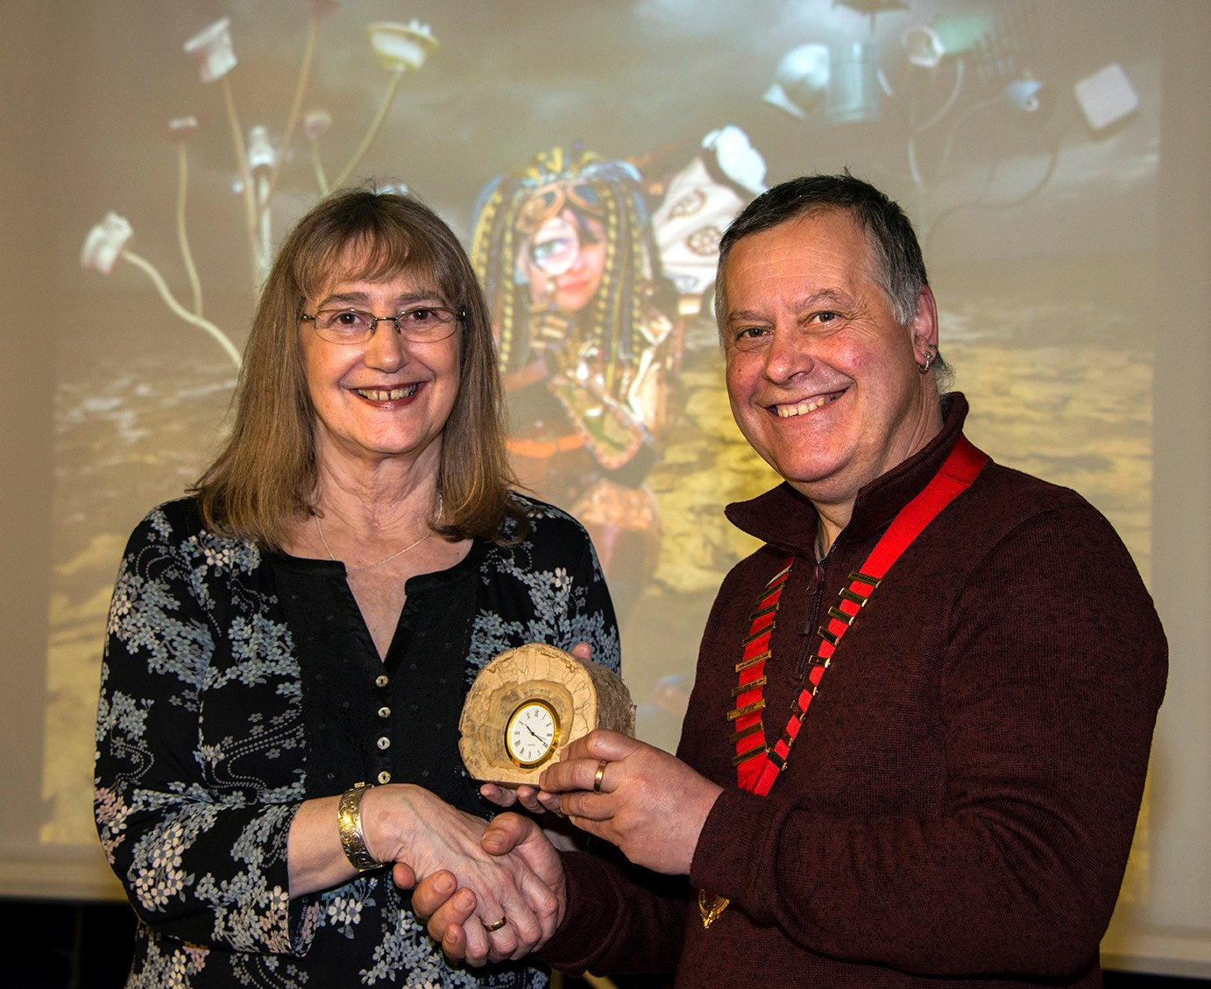
IOMPS President Tony Curtis presents our Annual Competition Judge Christine Widdall, MPAGB EFIAP FBPE with a clock encased in locally sourced wood
The IOM Photographic Society held its Annual Print Competition this week, and the members were privileged to have Christine Widdall, MPAGB EFIAP FBPE, President of the Oldham Photographic Society and a long-standing senior executive member of the Lancashire and Cheshire Photographic Union as their judge. She is an acknowledged expert photographer with years of experience, charm and charisma, and loaded with enthusiasm – so a packed audience eagerly awaited her commentary, and she did not disappoint! An entertaining and often amusing commentary with lots of helpful asides passed all too quickly.
As the sole entrant in the Standard section, Jonathan Carey’ s entries were judged as a group, his “Every Penny Counts” – a pleasing and well printed image of a young boy donating to a street musician – deservedly gave him a first place. In both the Intermediate and Advanced sections, the awards were well spread out, and demonstrated the wide range of talent in the Society. Barry Murphy swept the board in the Intermediate Mono section with a 1, 2 and 3, his portrait of “Tom Jackie” proving the winner. Hazel Walsh showed her skills, winning both the Colour section (with “The Bone Collector”) and the Creative (with “Man and Machine”, a composite of a rider and his motor-cycle). The Natural History section was won by Sue Leeming with her shot of a heron in Douglas Bay, whilst Shirley Lotfy completed the Intermediate group by winning the Record section with “Street Art, Belfast” – an image exactly as titled.
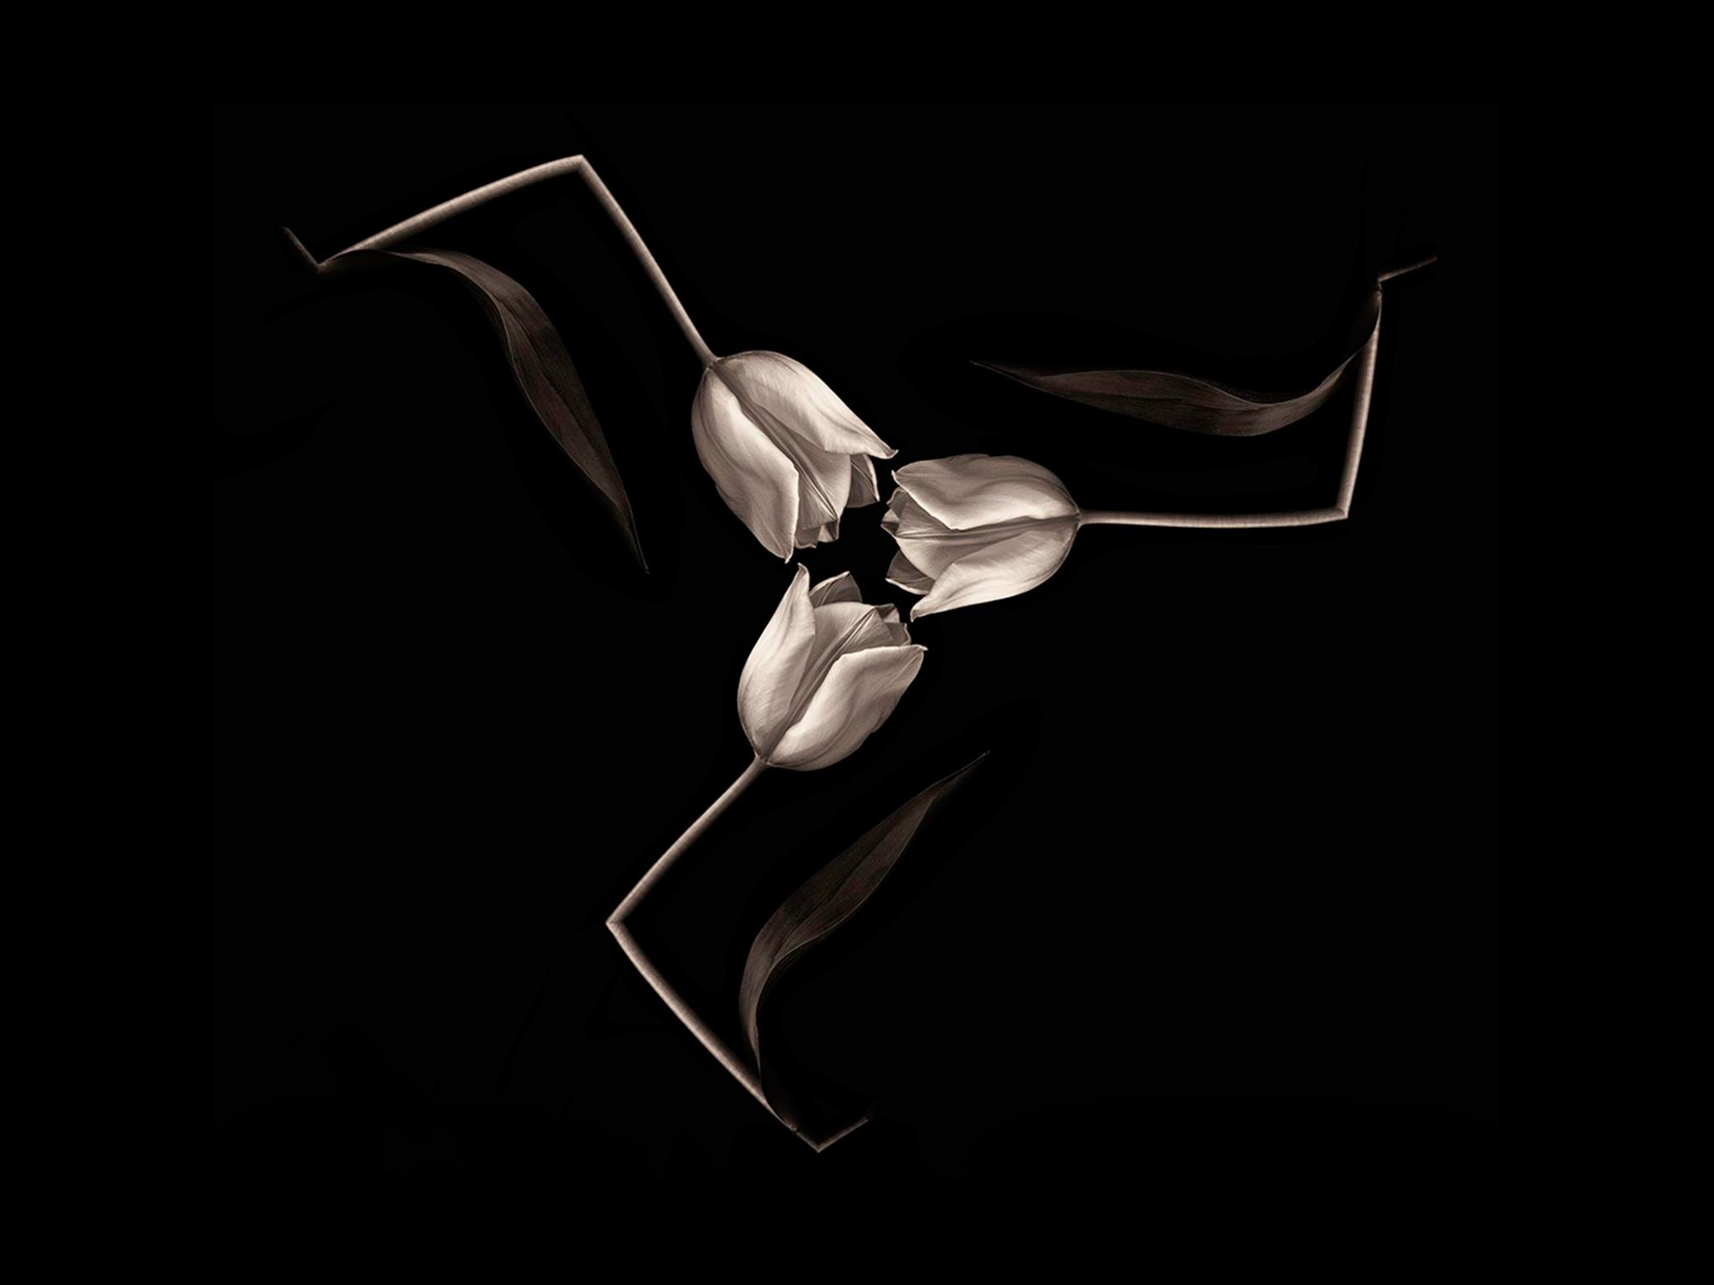
“Truelips of Man” by Nigel Owen was awarded Best Monochrome Print in the IOMPS 2017 Annual Competition
The Advanced group proved very competitive, with a large and high quality entry, particularly in the Mono and Colour sections. Nigel Owen showed yet again his mastery of Mono with “Truelips of Man”, a delightful shot of three tulips, the stems “bent” into the Manx triskele. Chris Blyth took the Colour section with “Frozen”, an image of two roses frozen into an ice block, whilst Sue Blythe’s beautiful shot of a mother polar bear and cub won her the Natural History section. A “Vase of Tulips” gained Ruth Nicholls the Creative section – the flowers given a very soft, diffused finish in a highly artistic treatment. The competition concluded with the Record section, Ron Shimmin taking both first and second place with two of his meticulously printed shots, the winner being “Lamentation Panel – the Louvre” a bas relief image of a sculpted marble panel, almost 3D in its effect.
Christine completed the evening with a presentation of some of her own images – with an emphasis on her joy at photography, and the fun aspects of her work. Reluctant to go anywhere without her camera, she made clear that the essential point was not to produce “competition standard” work but to take advantage of the light and whatever the weather conditions, to take images to enjoy – and just maybe, with serendipity, some exceptional images as a result – and which her presentation clearly showed. Landscapes of Saddleworth Moor (her home), Snowdonia and of the Lake District, pets at play in the river, architecture at Salford Quays all demonstrated high technical skill with a great eye for an image. Tony Curtis, Club President, gave the vote of thanks.
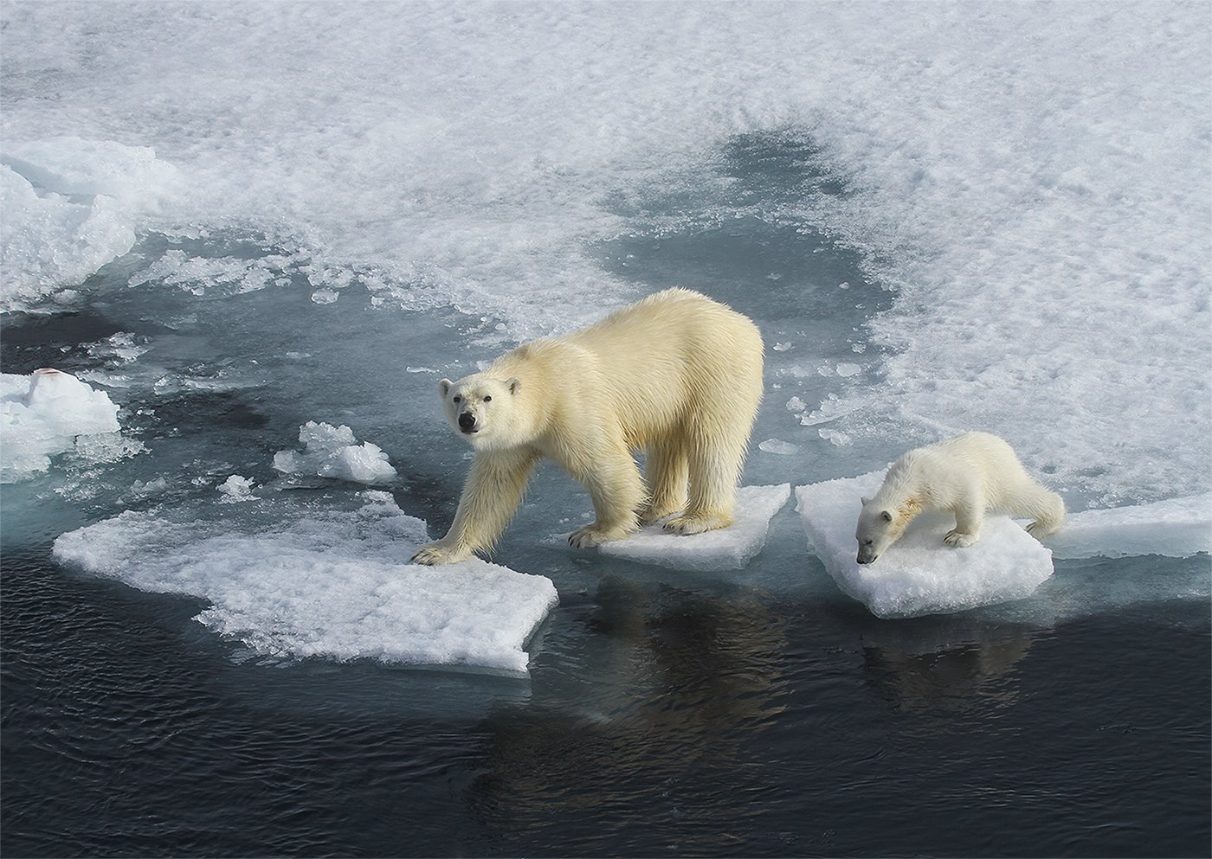
“Polar Bear and Cub” by Sue Blythe was awarded Best Colour Print and Best Natural History Image in this years Annual Competition
Results – Standard Group : Mono Prints – Jonathan Carey (VHC). Colour Prints (Woodbourne Cup) – Jonathan Carey (1 & 2). Intermediate Group : Mono Prints (Ballure Cup) – Barry Murphy (1,2 3 & 2xC), Sue Leeming (VHC & HC), Richard Shafto (C). Colour Prints (Coombe Cup)– Hazel Walsh (1 & C), Barry Murphy (2 & C), Sue Leeming (3 & 2xC), Joy Brodie (VHC). Natural History (Ballaragh Cup)– Sue Leeming (1,2 & VHC), Richard Shafto (3, VHC and C), Barry Murphy (C). Creative (Carnane Cup) – Hazel Walsh (1). Record (Lezayre Trophy)– Shirley Lotfy (1 & 3), Beryl Quayle (2). Advanced Group : Mono Prints (Bridge Cup)– Nigel Owen (1), Jeremy Broome-Smith (2), Sue Blythe (3 & VHC), Ruth Nicholls (2xVHC, HC & C), Bob Servante (HC & C). Colour Prints (Sanderson Cup) – Chris Blyth (1), Ruth Nicholls (2), Sue Blythe (3 & C), Jeremy Broome-Smith (VHC & HC), Bob Servante (VHC & C), Chris Nicholls (VHC), Janet Servante (HC). Natural History (Caraghan Cup) – Sue Blythe (1,3 & VHC), Jeremy Broome-Smith (2 & VHC), Chris Blyth (C). Creative (Snaefell Cup) – Ruth Nicholls (1), Jeremy Broome-Smith (2), Nigel Owen (3). Record (Glenrigh Cup)– Ron Shimmin (1 & 2), Chris Nicholls (3). Best Mono Print In Competition (Mackie Cup) – “Truelips of Man” by Nigel Owen. Best Colour Print (Redwood Trophy) – “Polar Bear and Cub” by Sue Blythe.
By Chris Blyth

27th April 2017 - Annual Competition 2017 – Digital

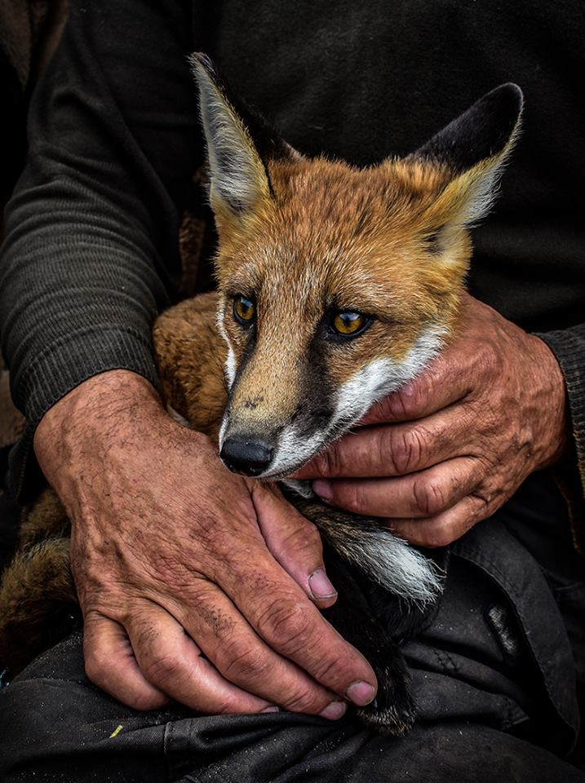
‘In Safe Hands’ by Barry Murphy gained Best Digital Image in this years Annual Competition
The annual photographic competitions are the high spot of the year’s work. Because of the importance of these competitions, a highly qualified judge from the Lancashire and Cheshire Photographic Union (L&CPU), to which the Society is affiliated, is invited to scrutinise the entries.
As was reported in the Courier recently, making a welcome return visit to the Island and to the Society, this year’s judge was Christine Widdall MPAGB, EFIAP, FBPE, a former President of the L&CPU.
On day two of our Annual competition Christine judged the Digital Projected Images. Being keen on personal development, she began by suggesting various ways in which the skills of club members generally might be improved. She then proceeded to give her personal opinion on the images she considered worthy of an award or special mention. Her natural enthusiasm and easy sense of humour shone through as she explained why these images had given her particular pleasure. She delighted her audience by saying how pleased she had been with the very high standard overall.
Her preferred approach was not to look specifically for weaknesses, but to concentrate on the positive aspects. She had been pleasantly surprised by the level of skill in handling the available light sources and her assessments on each image reflected their emotional appeal to her and the story the photographer was trying to convey. She had not found it easy to rank the entries because of the high standard but her choices were delivered with such clear authority that her conclusions were understood and accepted.
In the Standard Group, Patricia Larkham cleaned up with first, second and third in the colour section, her ‘Wells Cathedral’ taking the top honours. She then took first place in the natural history section with ‘Kingfisher’ and her ‘Christmas Altar’ came first in the record section. Michael Howland’s ‘Super Moon’ was awarded first place in the monochrome section.
In the Intermediate Group, Barry Murphy’s image of ‘A Grand Day Out’ was placed first in the monochrome section, whilst his ‘Puffin’ topped the natural history section. He won the colour section with ‘In Safe Hands’, which was also judged to be the best overall digital image across all sections. Beryl Quayle’s ‘Golden Eyes’ won the creative section and her ‘University Building, Liverpool’ was judged the best record shot.
In the Advanced Group, there was little to choose between many of the entries, such was the consistent standard. However, ‘Smokey Old Town’ by Chris Nicholls was selected as the best colour entry and his ‘Indoors People’ as the best monochrome image. Sue Blythe maintained her successful year by winning the natural history section with ‘Polar Bear Jumping’ and Ruth Nicholls came first in the record section with ‘Holocaust Memorial Venice Ghetto’. Jeremy Broome-Smith completed the list by winning the creative section with ‘Splash’.
The second half of the evening allowed Christine to impress us with a range of images featuring her own work, some of which had done well in national and international competitions.
Tony Curtis gave the vote of thanks for two entertaining days and presented Christine with a suitable memento of her visit.
RESULTS:
Standard Group :
Colour – (Henry Roy Welsh Memorial Cup) : Patricia Larkham (1st, 2nd and 3rd).
Mono – (Barrule Cup): Michael Howland (1st and 2nd).
Natural History – (York Trophy): Patricia Larkham (1st).
Record – (Atlantean Trophy): Patricia Larkham (1st); Michael Howland (2nd).
Intermediate Group :
Colour – (Brockenhurst Cup): Barry Murphy (1st and 2nd plus HC); Beryl Quayle (3rd and VHC); Sue Leeming (VHC, HC and C); Hazel Walsh (C).
Mono – (Glen Darragh Trophy): Barry Murphy (1st, 2nd, 3rd and VHC); Sue Leeming (VHC and C).
Natural History – (Jensen Trophy): Barry Murphy (1st and C); Joy Brodie (2nd); Sue Leeming (3rd).
Creative – (Sheiling Cup): Beryl Quayle (1st); Hazel Walsh (2nd and 3rd).
Record – (Summerhill Cup): Beryl Quayle (1st); Shirley Lotfy (2nd); Joy Brodie (3rd).
Advanced Group :
Colour – (Andrew Barton Cup): Chris Nicholls (1st, VHC and C); Sue Blythe (2nd); Jeremy Broome-Smith (3rd and C); Ruth Nicholls (VHC); Bob Servante (C).
Mono – (Glendown Trophy): Chris Nicholls (1st); Sue Blythe (2nd and 3rd); Jeremy Broome-Smith (C).
Natural History – (Kelly Cup): Sue Blythe (1st and VHC); Chris Blyth (2nd) ; Jeremy Broome-Smith (3rd); Ruth Nicholls (VHC).
Creative - (Malew Cup): Jeremy Broome-Smith (1st and C).
Record – (Dreeym Beary Trophy): Ruth Nicholls (1st); Chris Nicholls (2nd).
BEST OVERALL DIGITAL IMAGE : Barry Murphy with ‘In Safe Hands’ (from the Intermediate Section).
By Antony Hamilton

